

**APPLICATION OF MECHATRONICS IN AGRICULTURE:**

**A FOCUS ON IRRIGATION (Version 2.0)**

BY

**ALELE FAMOUS**

MATRICULATION NUMBER: 14CM017004

**DARANIJO EMMANUEL**

MATRICULATION NUMBER: 14CM017014

**&**

**ONYEUBANI PRECIOUS**

MATRICULATION NUMBER: 14CM017064

A PROJECT REPORT SUBMITTED TO THE DEPARTMENT OF MECHANICAL ENGINEERING, COVENANT UNIVERSITY, OTA, OGUN STATE,

NIGERIA.

IN PARTIAL FUFILMENT OF THE REQUIREMENTS FOR A BACHELOR OF ENGINEERING DEGREE (B.ENG.) IN MECHANICAL ENGINEERING.

APRIL, 2019

# DECLARATION

We hereby declare that this project on “Application of Mechatronics in Agriculture: A Focus on Irrigation II” is an original work done by us under the supervision of Prof. C. A. Bolu.

We also solemnly declare to the best of our knowledge, that this report has not been submitted here or elsewhere for award of a bachelor’s degree. All sources of knowledge used have been duly acknowledged.

_____________________

Signature & Date

Alele Famous

14CM014004

_____________________

Signature & Date

Daranijo Emmanuel

14CM017014

**_____________________**

Signature & Date

Onyeubani Precious

14CM017064

# CERTIFICATION

This is to certify that this project was carried out by Daranijo Emmanuel, Onyeubani Precious and Alele Famous under our supervision in the department of Mechanical Engineering, Covenant University, Ota.

_____________________ _____________________

Prof. C.A. Bolu Date

Supervisor

_____________________ _____________________

Prof. S. O. Oyedepo Date

Head of Department

# DEDICATION

We dedicate this project to the one who holds our past, present and tomorrow in His hands and knew us before our very existence.

We also dedicate this study to our families for their love and support throughout this project.

# ACKNOWLEDGEMENT

Our first and foremost gratitude is to our GOD Almighty who has been with us through it all, giving us strength to complete this project. To Him we owe the content and product of our intellectual capabilities.

We would also like to acknowledge our deepest gratitude to our project supervisor, Prof. C. A. Bolu whose constant commitment and contribution has made this project a success and also Engr. Joseph Azeta for his contribution to the success of the project.

Special thanks go to the Department of Mechanical Engineering for their permission to use the facilities and equipments available at the department, which aided us to complete the project successfully.

Special appreciation goes to our loving parents, riding along with us on our academic journey as well as giving us the encouragement to pursue our dreams. Thank you.

# ABSTRACT

Agriculture is an industry that uses a lot of water. Most of the time, this resource is not used efficiently and substantial amounts of water is wasted. In the near future, these wastes will represent have great impact on the ecosystem which will also cause an increase in the cost of water. This project is focused on improving the irrigation process in agriculture through the application of mechatronics. An automatic irrigation system is designed and developed by integrating several hardware and software features. The system is designed to determine when exactly the soil of crops need water and deliver a controlled amount of water to the root zone of the crops based on the soil moisture state. The system is designed to run 24/7 on renewable solar energy.

**TABLE OF CONTENTS**

DECLARATION ii

CERTIFICATION iii

DEDICATION iv

ACKNOWLEDGEMENT v

ABSTRACT vi

LIST OF FIGURES ix

LIST OF TABLES x

CHAPTER ONE 1

1 INTRODUCTION 1

1.1 BACKGROUND 1

1.2 PROBLEM STATEMENT 5

1.3 AIM AND OBJECTIVES 6

1.3.1 Aim 6

1.3.2 Objectives 6

1.4 SCOPE 7

1.5 LIMITATIONS 7

1.6 JUSTIFICATION 7

CHAPTER TWO 9

2 LITERATURE REVIEW 9

2.1 INTRODUCTION 9

2.2 APPLICATIONS OF MECHATRONICS IN AGRICULTURE 9

2.2.1 Precision Agriculture 10

2.2.2 Animal Production 10

2.2.3 Autonomous Tractors 11

2.2.4 Crop Seeding 11

2.2.5 Crop Monitoring and Analysis 11

2.2.6 Crop Weeding and Spraying 12

2.2.7 Crop Fertilization 13

2.2.8 Irrigation 13

2.3 IRRIGATION 14

2.3.1 Surface Irrigation 15

2.3.2 Sprinkler Irrigation 16

2.3.3 Drip Irrigation 18

2.4 REVIEW OF RELATED WORKS IN LITERATURE 19

CHAPTER THREE 23

3 METHODOLOGY 23

3.1 INTRODUCTION 23

3.2 MATERIALS 23

3.2.1 Materials and Components Description 23

3.2.2 Specification of Components 27

3.3 METHODS 33

3.3.1 Section A 34

3.3.2 Section B 39

3.3.3 Section C 41

3.3.4 Section D 44

3.3.5 Section E 54

3.3.6 Conclusion 55

CHAPTER FOUR 56

4 RESULTS & DISCUSSION 56

4.1 INTRODUCTION 56

4.2 RESULTS 56

CHAPTER FIVE 60

5 CONCLUSION AND RECOMMENDATIONS 60

5.1 INTRODUCTION 60

5.2 CONCLUSION 60

5.3 RECOMMENDATIONS 61

BIBLIOGRAPHY 62

# LIST OF FIGURES

Figure 3.1: Flow chart of Irrigation Mechanism 33

Figure 3.2: Farm Land 38

Figure 3.3: Sensing Unit Schematic 42

Figure 3.4: NRF24L01+ Module 42

Figure 3.5: Control Module Schematic 43

Figure 3.6: Power supply module 55

Figure 3.7: 3D model of the system 55

Figure 4.1: Brain box of the system 56

Figure 4.2: Water Storage Tank 57

Figure 4.3: Solenoid Valve (Installed) 57

Figure 4.4: Solar Panel (Installed) 58

Figure 4.5: Sensor box with distributed sensors 58

Figure 4.6: Automated irrigation system 59

# 

# LIST OF TABLES

Table 3.1: Soil Moisture Sensor Specification 27

Table 3.2: Arduino UNO (Atmega328P) Specification 27

Table 3.3: 8 Channel Relay Specification 28

Table 3.4: Solenoid Valve (AQT12SL) Specification 28

Table 3.5: Alphanumeric LCD (16x2) Specification 29

Table 3.6: Arduino Mega (Microcontroller – Atmega328P) Specifications 30

Table 3.7: DHT11 Sensor Specification 31

Table 3.8: Solar Panel Specifications 31

Table 3.9: Solar Charge Controller 32

# CHAPTER ONE

# INTRODUCTION

## BACKGROUND

In the actual foundation of agriculture, farmers employed power from bulls, cows and horses and would leave the residual labour for manual workers. As a major instance, two to three hundred work hours were essential to yield five acres of wheat with a walking plough, a hand broadcast of seed, a brush harrow, flail and sickle. Most of the essential time required in the agricultural process was to come by, due to the extensive amount that was spent on manual labour. In addition, the ineffective conducts of cultivating unlocked the doors for persons to be exposed to diseases and animal attacks (Bonifaz *et al.*, 2009).

The normal inclination on the road to change journeys us through a sequence that envisions us to convey our knowledge and technology in the designing of the future of agriculture. We began agriculture with simple handmade cultivating tools, and then further progressed with power machinery with an idea of increased efficiency, but we were blind to the impairment that was created to the environment. With the influence of Mechatronics in agriculture, our ecology is gradually returning to its “green” state while also dropping cost and increasing efficiency by diffusing it with technology that is not destructive but advantageous (Bonifaz *et al.*, 2009).

Agriculture is the oldest industry, dating as far back as the nomadic age. It originally depended solely on human effort, then apprehended animal labour, and then came mechanical advances such as diesel/steam-engine tractors and mechanical tools with hydrostatic power which needed control. The answer to unresolved problems relies on more advances that necessitate the replacement of human intellect to meet the requirements for superior autonomy in more indefinite and unstructured environments. Promising disciplines in this framework include Mechatronics, Large-scale optimization and Complex system automation. Necessity is driving the implementation of information technologies into agricultural technologies, it could be in the guise of a process controller, a machine, or a management and planning system (Sigrimis *et al*., 2001).

From the history of progressions in technology, the evolutions of the world that we have created for ourselves can be traced back. Throughout the Industrial Revolution, the use of factories and steamships were praised without any regard to how detrimental they could become to our planet. With Mechatronics engineering, and merging disciplines that are not just related to science and technology alone, but also the organic terrain surrounding us, we can progress by working backwards. After having created agriculture and machinery, devolution turns out to be the key to evolution based on the principles of applying Mechatronics to convey an industrialized world back to its origin of a healthy “green” ecology. (Bonifaz *et al.*, 2009).

Technology today plays the role of a feeding hand to agriculture. Elements of Mechatronics, such as sensors, play vital roles in our farms of seeding, cropping, cleaning, fertilizing and monitoring our vegetation. Today, sensors are applied in detecting colour, ambient light levels, alcohol levels for ripeness, moisture levels and dangerous levels of chemicals including insecticides and pesticides. Different mechanisms have also been designed and constructed to aid agricultural processes, for example, robot arms that nurture the roots of plants and revolving machines to seed, collect, and clean produce, and to regenerate the soil (Bar-On and Hessel, 2003).

Mechatronics is an aspect of engineering that centres on designing, producing and maintaining products that are made up of the integration of both mechanical and electronic components. The history of Mechatronics began in 1969 with an employee at Yaskawa Electric Corporation, Tetsura Mori (Rohde, 2009). The term Mechatronics is obtained from the two wide-ranging disciplines of electrical and mechanical engineering, and are bridged by computer science. Mechatronics is now being applied in numerous components of technology that can be found in the modern world.

The application of Mechatronics in Agriculture can be traced back to the 1980s, when research on automated systems for fruits harvesting turned up in USA, Japan and Europe. Since then, remarkable developments have been attained in advanced learning and cognition, perception and sensing, planning and navigation, cooperation and communication, manipulation and actuation, among Mechatronics systems. These progressions allowed Mechatronics systems to challenge rather complex tasks even in challenging and dynamic environments.

The agricultural sector is quickly being changed into an industry of key importance that must depend seriously on advanced control systems and computer-aided management. These technologies are indispensable components of the succeeding generation of animal and plant “factories” in the new era. Contemporary agribusiness is becoming progressively dependent on automation, robotics and computer-based systems, that are taking over many of the dreary jobs previously carried out by humans, and in most cases with superior performance. To manage the growing intricacy of agricultural systems, progressively sophisticated practices are required. (Sigrimis *et al.,* 2001).

In contemporary, multifaceted agricultural facilities numerous Mechatronics and embedded systems, such as microcomputers and microcontrollers, are already in application. These autonomous elements are the foundation and building blocks of a modern agricultural complex. The basic of today’s modern agriculture is the precision agriculture (PA), where crop production is made more effective using sophisticated control systems. The essence of precision agriculture is essentially the manuring and irrigating by needs and with high precision (Erdélyi and Jánosi, 2017).

Several of the innovations presented to agriculture by the scientific and Industrial revolutions paved the path for a qualitative transformation in the nature of agricultural production. Various helpful effects have been attained by the application and integration of technology in agriculture. It has not just lessened the labour, but it has also decreased the cost of crops by producing massive yield (Imadi *et al.,* 2016). It has also permitted agribusinesses and farmers to export a large portion of their produce to other nations. Farm exports have permitted farmers to increase their markets and have contributed to supporting a nation’s trade balance. There are several other factors that affect high yield in crop production, these include:

* Proper tillage practices
* Use of high yielding variety
* Prepare seed bed properly
* Crop rotation
* Multiple cropping system
* Proper seed rate
* Proper time sowing
* Balance fertilizers
* Proper irrigation
* Control of pest and diseases, weeds
* Time of harvesting (Abbas, 2011).

Irrigation is the process of artificially supplying water to land or soil. It is used to aid in the growth and development of agricultural crops, revegetation of damaged soils in dry areas, maintenance of landscapes, and during periods of insufficient rainfall (Kumar, 2014). Water is a resource that is needed by all living things. It is very valuable and needs to be used with moderation so as to preserve it for as long as possible. Agriculture is an industry has very high-water consumption. More often than not, water is not used efficiently and significant volumes of water are misused. Very soon, these wastes will lead to water costing large sums of money (Raju, 2017).

Irrigation is adopted everywhere in the world where rainfall does not deliver sufficient soil moisture. In places of asymmetrical rainfall, irrigation is used during dry seasons to guarantee harvests and to increase crop returns. Irrigation has significantly increased the amount of cultivatable land and the food production all over the world. In 1800 about 8.1 million hectares (about 20 million acres) were under irrigation, a figure that rose to 41 million hectares (99 million acres) in 1900, to 105 million hectares (260 million acres) in 1950, and to more than 273 million hectares (675 million acres) today. Irrigated land embodies about 18 percent of all land under cultivation but frequently produces more than twice the output of non-irrigated fields. Irrigation can, however, increase a soil's salt level or waterlog soil to a point in which crops are damaged or ruined. These problems now jeopardize about one third of the world's irrigated land (Abbas, 2011).

The scope of this work is to come up with a solution to increase crop yield while considering adequate agricultural water management and labour reduction, by the application of mechatronics in the irrigation process. We will make use of the Arduino Uno microcontroller for the decision-making process of the system; this is due to its availability and the ease of programming the Arduino Uno hardware. The microcontroller with the data obtained from the soil at the roots of the crops will determined how much water for irrigation is needed at a point in time, and the supplies it, thereby incorporating good water management practice.

## PROBLEM STATEMENT

* The rate at which the world’s population is growing is quite alarming. This growth is evident in nations having deficient water resources and are economically meagre. Due to this population growth, there is an enormous need to increase food production by 50% in the next 50 years in order to maintain sustainability, this is based on the assumption that there will be no decline in the output of existing farmlands. The means that water resources need to be managed efficiently (Jain *et al.,* 2016).
* Currently, there is a developing worldwide water crisis where management of water scarcity has developed into a dreary job and there are struggles between employers of water. This is a time in which the human use of water and water pollution have surpassed the points which lead to the limitation of food production and decline in the ecosystem. Therefore, whatever amount of water we have left must be used optimally and managed properly (Jain *et al.,* 2016).
* It is safe to call water the most important liquid on the surface of the earth. Water is probably the most excessively used resource on earth. Mass irrigation is a commonly used technique in the watering of crops in agriculture. This technique signifies immense wastage since the quantity of water given is in surplus of the crop’s requirements (Leroux and Raghavan, 2005).
* In the application of traditional irrigation methods, water saving is not considered. Due to the fact that the water is irrigated directly on the land, crops sometimes undergo increased stress from disparities in the soil moisture, consequently crop performance and output is reduced. The absence of an appropriate water control system results in improper use and wastage of water (Tyagi *et al.,* 2017).
* Irrigation of crops is a significantly time-expending activity; to be done in a feasible amount of time, it also demands a huge amount of human resources. Conventionally, all labour required in the irrigation process were carried out by humans (Leroux and Raghavan, 2005). Also, the cost of labour is on the increase. As a result of this, if efforts are not invested into the optimization of these resources, additional money will be required by the same processes. Technology in the form of Mechatronics is a feasible solution to decrease costs and avert wastage of resources (Angal, 2017).

## AIM AND OBJECTIVES

### Aim

To supply the optimum amount of water required to crop roots during periods of low humidity and high temperature.

### Objectives

* To cultivate a ten-meter square(10m2) farm for beans, maize and tomatoes.
* To determine when each crop needs water.
* To design a system to efficiently supply water to crop roots.
* To determine the effectiveness of the system by comparing performance with a control setup.

## SCOPE

* The project involves the design and construction of a drip irrigation stem that is mechatronically controlled by an Arduino microcontroller. The controlled element of the irrigation system are the pumps and valves which will be actuated to provide water to the irrigation point(area).
* The designed system will be tested with tomatoes, corn and cowpea which have relatively short mature period. The growth and performance of the crops under irrigation will be monitored and recorded and then compared with the performance of the same crops on a separate mass irrigated control plot.

## LIMITATIONS

* The soil to be used in experimentation is limited to type found in geographical region of Covenant University, Ota, Ogun State.
* The experimentation is limited to the cultivation of three (3) crops - beans, maize and tomato.
* The project time frame is limited to April 2019.

## JUSTIFICATION

The ever-growing population has led to an exponential surge in food demand. This occurrence has demanded the necessity for supplementary land to be cultivated. Global warming has brought about changes in weather patterns, this means that irrigation is the only dependable method for crops cultivation. Progressively more lands are now being placed under irrigation, this means that there is an urgent need for the optimal use of water (Njoroge, 2008).

Irrigation systems in crop cultivation can be automated using the microcontroller. Automated irrigation systems are one of the most efficient, effective and convenient technique of water optimization. The systems help in conserving water and reducing wastage, thereby enabling more land to be put under irrigation.

Furthermore, a controlled irrigation will make possible all year-round farming of crops. Also, crops cultivated under controlled conditions have a tendency to be healthier. This means that more and better yields are harvested all throughout the year.

In addition, this project will raise awareness locally about the benefits of drip irrigation technology in agriculture, which includes decrease in cost due a reduced need for labour. Also, the drip irrigation system will avert the washing off of fertilizers thereby reducing waste and costs.

# CHAPTER TWO

# LITERATURE REVIEW

## INTRODUCTION

Water, perhaps may be the most vital substance on earth – we cannot survive without it. But the increasing demands on our water resources means that, now more than ever, there is an important need to manage our water usage in order to guarantee there will continuously be adequate to go around. Although one-third of the world’s population is already affected by water scarcity, the world is set to undergo even further fresh water constrictions due to problems such as an increasing world population, climate change, and also pollution. Just like global energy use, quick and conclusive actions must be taken to prevent the water wastes that are taking place all around the world so that we create a sustainable future for ourselves and the environment. Due to the fact that 70% of global water resource is used in agriculture, and because about 60% of that water is actually wasted through runoff or evapotranspiration, a massive impact on global water conservation can be made if we re-examine our water usage in agriculture (Greentumble, 2016). This project seeks to reduce the amount of water that is used in agriculture by making irrigation as efficient as possible through the application of an automated drip irrigation system. The irrigation system will optimize the irrigation process by only watering when and where water is required. Soil moisture will be measured directly to ascertain the current water needs of each plant. Also, drip irrigation will be used so that only the plant’s roots are watered instead of the surrounding soil as well.

In this chapter, some of the applications of mechatronics in agriculture are discussed. Drip irrigation and other irrigation techniques are also discussed in order to obtain a greater understanding of the process and the project in general. In this chapter, insights into existing and up to date information about this project is provided through the review of previous technical and academic efforts made by various authors.

## 2.2 APPLICATIONS OF MECHATRONICS IN AGRICULTURE

Mechatronics is an interdisciplinary branch of engineering involving the knowledge area of mechanical, electrical and computer engineering disciplines. Mechatronics caters to the needs of industrial processes and commercial products that require the integrated use of mechanical and electronic components, and also the application of control software during their design and development (Imam and Bicker, n.d.).

Mechatronic systems are used in different sectors/fields of application, such as agriculture, automotive, health, lifestyle and consumer products, etc. Current and future mechatronics are developed based on the technological trends required to better and make easier human living and sustain the environment. Mechatronic systems help provide a competitive advantage in a harsh industrial environment (Dieterle, 2004). As a result, mechatronics has found quite a number of useful applications in agriculture.

### 2.2.1 Precision Agriculture

In the 1980s, precision agriculture was first applied in industrial manufacturing, it concerns the application of sensors, mechatronics and automation to improve efficiency of monitoring and interference techniques. The dawn of mechatronics and autonomous systems allows us the chance to create a new range of agricultural equipment based on little, smart technologies that reduces waste, environmental impact, progresses economic capability, and increases food sustainability. Also, sensory data obtained by robotic platforms in the plantation provides affluent information and insights into yield optimization, improved planning, level of resources needed, and when and where the resources are needed in order to reduce waste and improve yields (Duckett *et al.,* 2018).

### 2.2.2 Animal Production

In the past decade, animal production has been introduced to a number of innovative technical tools in farms so as to aid decision making, particularly for management, feeding strategies, animal health and fertility. In addition, special electronic systems have been created in order to process the related variables and to provide the farmer with the appropriate tools and alert signals. With the progressions in mechatronics, biosensor technology has great potential for improving animal welfare, health and production efficiency (Nääs, 2002).

### 2.2.3 Autonomous Tractors

Tractors are the toilers of modern mechanized farms. Tractors are used for several agricultural processes. When equipped with the proper riggings, tractors can till, fertilize, plant, spray, weed, mow, haul and harvest. Such flexibility makes tractors an important equipment to be automated. Mechatronics has allowed for the automation of these machines thereby increasing productivity, improving safety, and reducing costs for many agricultural procedures. Stentz *et al.,* (2002) presented a system for tractor automation in which a task is programmed by driving the relevant routes. The task is then broken down into subtasks and assigned to a convoy of tractors that drive different parts of the routes. Each tractor is equipped with on-board sensors to detect people, animals, and other large objects in the path of the machine, halting for such obstructions until an instruction is given from a supervisor over a wireless connection.

### 2.2.4 Crop Seeding

Seeding is one of the major agricultural procedures in a crop cultivation. Appropriate seeds selection, sowing process and acknowledging the agricultural dates has a significant impact on the final yields. Today, with the aid of mechatronics, automated combined tilling-and-sowing machines are available to carry out the once tedious process. The machine allows for both ploughing and minimum tillage as well as for concurrent sowing cereals and catch crops. The application of this machine allows for soil preparation and sowing in a single pass. The use of a tilling-and-sowing combined machine will progress the economic and agronomic impacts (Szczepaniak *et al.,* 2014).

### 2.2.5 Crop Monitoring and Analysis

Gore *et al.,* (2016) proposed a using Wireless Sensor Network in order to create a low cost agricultural remote monitoring and controlling system. The sensor network is made up of minute autonomous devices called sensor nodes. The major objective is to monitor and control the environmental requirements of each specific plant. The Wireless Sensor Network is made up of small, low cost wireless sensor nodes. Each node observes, senses and gathers data intermittently and then sends this information to the base station. The system is based on Zigbee which is a low power wireless communication device. A microcontroller serves as the brain of the system which controls all the sensors, activates it and runs them in harmonization.

### 2.2.6 Crop Weeding and Spraying

Åstrand and Baerveldt (2002) presented an autonomous robot for agricultural weed control. The robot uses two vision systems: one gray-level vision system that is able to recognize the crop row formation and to guide the robot along the rows and a second, color-based vision system that is able to identify a single crop among weed plants. This vision system controls a weeding-tool that removes the weed between the row of crops. The row-recognition system runs on a novel algorithm and has been tested and proven to be able to guide the robot with an accuracy of ±2 cm. It also has a main computer runs under a real-time operating system, and controls all the robot’s systems and actions.

Chang and Lin (2018) proposed a multi-functional intelligent machine for automatically removing weeds while also allowing for flexible rate irrigation. The machine has a digital camera for capturing images of growth areas under the machine in real time and use HSV and adaptive threshold methods to distinguish crops from weed zones and estimate the wet distribution area of the surface soil, such that the machinery can automatically respond to specific areas with weeding or watering. This system allows for the weed removal without harming the cultivated crops.

Spraying pesticides and weed killers onto fields can be wasteful, and also harmful to the environment. Application of mechatronics provides a smart system which is much more efficient. A smart spraying system in agriculture is a targeted spraying system with efficient application of chemical and low cost for the environment. It generally comprises of a targeted detection system and spraying system, in which the targeted sensor is the basis of the precision spraying system. The smart sprayer has a decision system that collects information in target areas and make spraying decisions. Several sensing techniques are used, such as, remote sensing, machine vision, spectral reflectance and so on. Based on the detection results of characteristics, species classification, disease symptom identification and damage severity evaluation, the spraying system controls the sprayer operation (Song *et al.,* 2015).

### 2.2.7 Crop Fertilization

Soil fertility is very significant factor in determining soil quality, as it shows the degree to which it can sustain crop life. Soil fertility is determined by the amount of macro and micronutrients, water, pH etc., present in the soil. In the case of deficiency, fertilizers are added to the soil in order to maintain high nutrient level. Amrutha *et al.,* (2016) proposed and designed an automated system for the measured addition of fertilizers to soil so as to prevent deficient/excess fertilizers in the soil. The system consists of three main parts: sensor system, microcontroller, dispensary system.

Currently, there are developments being made in advanced application systems for targeted crop fertilization. Photographs of the plantation are taken via satellite and then decoded to make available data on the state of every part of the plantation. A program for fertilizing the entire plantation will then be created bearing in mind the soil state, type of crop, weather conditions, etc. The program will then be loaded to the control unit of mechatronic dozing device on the tractor. The tractor with the aid of GPS and auto-guidance will then carry out the application of fertilizer (Grau *et al.,* 2009).

### 2.2.8 Irrigation

Irrigation is the artificial application of water to the land or soil. It is used to assist in the growth of agricultural crops, especially during periods of inadequate rainfall. About 85% of freshwater resources on Earth is used in agriculture. The population of the world keeps increasing and with it the demand for food. This means that our water usage can only but increase. So, there is an urgent need to create strategies for sustainable use of water. One of the best strategies to achieve such goal is the application of science and technology (Patidar and Belsare, 2015).

Irrigation is a very indispensable factor in crop farming. Irrigation has always been an ancient practice which has evolved through so many stages over the years, there are various methodologies that have been applied to achieve proper irrigation. Manual irrigation using buckets and watering cans, flood irrigation, drip irrigation, sprinkler irrigation are some methods still in use today. Most farmers apply irrigation by manual means which is effective for small scale farming. But the larger the farmland, the greater the need for a better means of irrigation, hence, an automated irrigation system. (Umeh *et al.,* 2015).

High quality irrigation water is becoming increasingly scarce and it is becoming more important to use the available water efficiently. An approach to more efficient irrigation and uses of water is the use of soil moisture sensors to control the irrigation process. Soil moisture sensors can detect when the soil water content drops below a defined set point. This makes it possible to automatically turn on the irrigation when needed. This maintains a well irrigated field whilst reducing water wastage (van Iersel *et al.,* 2009).

Irrigation is the unnatural application of water to soil in order to assist in the growth of crops in dry areas and during seasons and times of insufficient rainfall. Irrigation systems use the application of valves to turn ON and OFF the supply of water for irrigation. These can be automated by the use of solenoids and controllers. More so, farmers with the aid of automation can irrigate at the required time and also reduce overflow from over watering. which will improve crop performance by ensuring adequate water and nutrients when needed (Pasha and Yogesha, 2014).

## 2.3 IRRIGATION

Irrigation is the process of artificially supplying water to land or soil. It is used to aid in the growth and development of agricultural crops, revegetation of damaged soils in dry areas, maintenance of landscapes, and during periods of insufficient rainfall (Kumar, 2014). Irrigation supports the growth and development of agricultural crops. It also helps to revegetate disturbed soils and maintain landscapes in arid zones and during seasons of low rainfall. In distinction, farming that depends only on direct rainfall is referred to as dry land or rain-fed farming (Wikipedia, 2019).

Agriculture requires and uses water in high quantity. This makes water wastage a big problem in agriculture every time surplus water is given to the fields. There are a few techniques that are used to save or to control wastage of water from agriculture.

* Ditch Irrigation: ditches are dug out and seedlings are planted in horizontally aligned pattern. Water is made to move to different canals via siphon tubes.
* Terraced Irrigation: land is cut into multiple steps and supported by keeping walls while the plain areas are used for plantation and the idea is that the water runs down each step watering each column.
* Drip Irrigation: water is dropped near the root level of a plant in a slow steady motion.
* Sprinkler System: overhead sprinklers fixed on permanent risers, the sprinklers level up when water pressure increases.
* Rotary Systems: sprinklers move in circular direction covering larger areas (Deo Kumar *et al.,* 2017).

The three main methods of irrigation are surface, sprinkler and drip irrigation. Surface irrigation (flood irrigation) is application of water over the soil surface with the aid of gravity. It is the most common method of irrigation in application. Sprinkler irrigation applies water to soil by sprinkling or spraying water droplets from fixed or moving systems. Drip irrigation (trickle irrigation) applies water to the plants by dripping water slowly into the plants’ roots. It is implemented with the use of tubes that deliver water directly to the roots of the plant. This method saves water and prevents the loss of soil nutrients (Awati and Patil, 2012; Bjorneberg, 2013).

### 2.3.1 Surface Irrigation

Surface irrigation is a commonly used method in the irrigation of crops in a field, it involves the introduction and dispersal of water on the soil surface of the field and relies on gravity flow of water through the soil to the roots of the crops. The soil stores water and acts as the medium over which water is conveyed as it spreads and infiltrates. Irrigation water generally penetrates into the root zone during transference and reduction of water at the soil surface (Khatri and Smith, 2011).

Furthermore, in surface irrigation, water can be applied by a conduit located at an upper elevation of the field. Water may be dispersed to the crops in long parallel strips, in smaller rectangular basins or in small channels between crop rows. Surface irrigation methods can be classified into two - flooding method and furrowing methods. In flooding method, water is made to cover the entirety of the soil but the water used in furrowing method covers just a portion of the soil surface. (Sharma and Singh, 2008).

According to AFED (2008), surface irrigation is the cheapest and easiest method, but is usually greatly inefficient as less than 10% of water dispersed is used by the plant. In addition to the inefficient use of water, surface irrigation can often be labour intensive. Unfortunately, surface irrigation systems are found to be the most commonly used methods of irrigation all over the world (Koech *et al.,* 2010).

### 2.3.2 Sprinkler Irrigation

Sprinkler irrigation is an irrigation method which involves the application of water in a way similar to natural rainfall. In this system, water is dispersed by pumping and spraying into the air through sprinkler heads. This allows the water to be broken into small droplets which fall onto the soil like rainfall. The sprinkler heads disperse water uniformly over the surface of the soil, this makes the method efficient for minimal to wide-ranging coverage of land areas (Oseko, 2016).

Sprinkler irrigation method involves the distribution of pressurized water through nozzles or perforations by spraying over a plantation like regular rainfall. The water pressure is provided by a pump. A well-designed sprinkler irrigation system applies only the definite water necessary for retaining the soil moisture, thus attaining efficient water use. Compared to the common surface irrigation, sprinkler irrigation system significantly decreases the water use and also increases crop productivity (National Bank for Agriculture and Rural Development, 2007).

Shankar *et al.,* (2015) classifies the different sprinkler available into the various types detailed below:

* **Based on method of water application**

Rotating Sprinkler-Impact sprinkler, gear driven, reaction type and fixed head sprinkler

Perforated pipe system

* **Based on portability**

Portable system

Semi-portable system

Semi-permanent system

Permanent system

* **Based on precipitation rates**

Low volume sprinkler

Medium volume sprinkler

High volume sprinkler

* **Based on principle of operation**

Whirling sprinkler

Turbo hammer sprinkler

Propeller sprinkler

Mini-sprinkler

* **Based on movement**

Set move irrigation system

*Hand move*

*Tow move*

*Side roll*

*Gun type*

Solid set system

Continuous move system

*Center-pivot*

*Linear move*

*Traveler*

Sprinkler irrigation method has been adopted in many communities and individuals in small and large scales. This is because this system is readily available, easy to install and provides high water efficiency. Nevertheless, the high investment costs, along with high fuel costs required for running the pressure pumps, constitute a major constraint. This is the common reason why the employment of this system is unsuccessful and discarded (Smith *et al.,* 2014).

### 2.3.3 Drip Irrigation

Drip method is a method of irrigation used in conserving water usage in agriculture. In drip irrigation, water is sustained at a constant level as water is delivered to the plant roots, drop by drop. This is essential because it reduces water use and ensures the survival of the crops and avoids damage to crops due to excessive irrigation (Prathyusha and Suman, 2012). This makes drip irrigation the most advanced method of irrigation with the highest application efficiency. This is due to the fact that water is delivered only to the root zone of each crop which is where the water is majorly needed (Phocaides, 2007).

There are two major ways in which drip irrigation is applied for crop cultivation—surface drip and subsurface drip. With surface drip irrigation, the tubing or pipe is installed on the soil’s surface, in a groove, or just beneath the soil surface. However, in subsurface drip irrigation, the tubing or pipes are installed just under the soil. This reduces the sideways movement (sometimes called “snaking”) of the tubing or pipe due to temperature fluxes (expansion and contracting of the plastic) or movement due to wind. Subsurface drip irrigation makes use of thick-walled tubing or pipes buried in the soil at a depth below tillage equipment. The concept behind subsurface drip system is that the irrigation installations will be more permanent (Hochmuth, 2017).

Drip irrigation is an effective system of irrigating crop soil directly at the root zone and thus, reduces conventional losses like deep percolation, soil erosion and runoff. In contrast to surface irrigation, drip irrigation is more appropriate and cost-effective if it is applied in dry areas having undulated topography, shallow and sandy soils. This system also allows the use of fertilizers, pesticides and other water-soluble chemicals along with the irrigation water thereby ensuing higher outputs and better-quality harvest. This is why drip irrigation system is today viewed as the solution to many of the problems in dry land cultivation and for increasing the efficiency in irrigated cultivation (Sathyapriya *et al.,* 2017).

The inefficient use and wastage of water that occurs due to the use of surface irrigation has been reduced by the application of drip irrigation method. Furthermore, the environmental problems, such as salinity and waterlogging, encountered during the use of surface irrigation are entirely absent in drip irrigation. Drip irrigation helps in achieving increased efficiency of water-use, increased crop harvests, higher quality products, decreased tillage requirement, and higher fertilizer-use efficiency (Kumar and Palanisami, 2010).

## 2.4 REVIEW OF RELATED WORKS IN LITERATURE

Soil moisture level can usually be determined via two methods, direct soil sampling method or indirect soil moisture detecting method. The direct method of determining soil water content is not generally applied for irrigation anymore because they require a lot of labour and cannot provide instant feedback. Thanks to technological advancements, soil moisture sensors can be permanently positioned at strategic locations in a crop plantation in order to obtain repeated moisture readings that can be used over time for irrigation management (Muñoz-carpena and Dukes, 2014).

An automatic decision support system was designed and developed to control irrigation. The major property of the system is its use of constant soil measurement and climatic conditions to accurately determine how much irrigation the crops need. The application of instantaneous data from the soil in a feedback control system makes the decision support system very adaptable. (Navarro-Hellín *et al.,* 2016).

A system has been created to optimize the water use in crop plantation. The system automates the irrigation process by implementing a wireless network of soil-moisture, temperature and humidity sensors. The sensors are placed into the root zone of the plant thereby allowing for the determination of the exact field state allowing for precise regulation and control of water wastage in the field by using the automatic. The monitoring of the system is carried out with the aid of ZigBee and GSM (Patidar and Belsare, 2015).

An instantaneous intelligent sensor arrangement was designed for determining soil temperature and moisture content. The arrangement is made up of several sensor nodes positioned all around the farmland and a central receiver connected to a laptop/computer. The sensor nodes are made up of a peculiarly designed circuit board, soil moisture sensors, thermocouples, and a Radio Frequency Identification (RFID) tag that sends information to the central receiver. This is a closed loop irrigation system whereby the intelligent sensor arrangement will resolve the timing and quantities for instantaneous irrigation implementation (Vellidis *et al.,* 2008).

An automatic irrigation system is integrated with an Arduino UNO microcontroller that is set and programmed to send a signal to the irrigation system based on the moisture content of the soil. The amount of moisture in the soil is determined with the aid of soil moisture sensor. When there is a change in the moisture level, the sensor sends a signal to the Arduino (microcontroller). With the aid of a water level sensor, the microcontroller confirms that there is sufficient water in the overhead tank and then activates or deactivates the irrigating system accordingly. The designed system helped in improving plant growth, reducing costs, minimizing water wastage and reducing labour (Okoye *et al.,* 2018).

Fisher and Kebede, (2010) developed and constructed a system to automatically obtain and save specific environmental data in crop plantations. These data include air temperature, soil temperature, and soil moisture level. The system makes use of a microcontroller-based circuit in order to achieve automation. This allows for sensor power, and data storage and retrieval functions. Dependability of data retrieval and storage was found to have an average of 91%, where most lost or bad data occurred during times of severe weather and electrostatic disturbances.

A microcontroller based automatic irrigation system was designed to allow for the irrigation of regions of a field where water is needed, while circumventing regions where suitable soil moisture is detected. Each region requiring irrigation had at least one sprinkler head, water dispensing device and a solenoid valve with "on" and "off" state to control the movement of water. The regions had moisture sensors positioned in the soil, which measure and sends the moisture level of the soil to a microcontroller joined in controlling connection to the solenoid valves. The microcontroller, which includes the circuitry and software selectively triggers each solenoid valves on a given irrigation day, starting with the pre-programmed start time and lasting for a pre-programmed time period unless that period is shortened because the moisture sensor for that region indicates that the predetermined adequate moisture level has been obtained (Rajpal *et al.,* 2011).

A system was developed to automate water supply for irrigation of home garden and farm fields. It was carried out through the use of moisture and temperature sensors which are installed at root area of the crops. The values detected by the sensors are sent to a base station where real-time data from the field is collated and uploaded to the internet using ESP8266 Wi-Fi module. The station also notifies the user concerning any irregular conditions like low moisture and high temperature. Whenever the detected value is more than the set point the valve of irrigation system is triggered open. Technological advancements as we approach Internet of Things (IOT) makes it possible for the user to continuously monitor the state of the soil. (Kumar and Ravi, 2016).

A SCADA-based system is useful in places where there is adequate sunshine but deficient water to perform the required farming activities. An automated SCADA system that uses a Programmable Logic Controller (PLC) is very significant in agriculture. The system can be energized by a smart solar system with solar panels that target The Sun’s radiation. The system works using soil moisture and level detection sensors. Soil moisture sensor detects the moisture content, whereas the level detection sensors detects the water level in the water tank. The biggest gain of solar energy is that it is a freely available, unlimited source energy (Abdelkerim *et al.,* 2013).

Agbetuyi *et al.,* (2016) designed an automatic irrigation system to eliminate the stress of manual irrigation and also conserve water usage. Increased irrigation efficiency greatly reduces the cost of production agricultural products, thereby creating a more competitive and sustainable industry. Furthermore, a microcontroller integrated with sensors should be used to help monitor the soil moisture content and control water usage thereby saving water.

# CHAPTER THREE

# METHODOLOGY

## INTRODUCTION

This chapter presents a detailed insight into the materials used to carry out the project and also the systematic approach used, while giving reasons for the choice of each component and methods used.

The chapter proceeds with a detailed description of each material and component, calculations and flowchart algorithms, and concludes with the sequential procedures followed.

## MATERIALS

### Materials and Components Description

#### Soil moisture sensors (SMSs)

This device is used to approximately determine the humidity content of the soil based on the dielectric constant (soil bulk permittivity) of the soil. Precise water content measurements of the soil is essential for grasping the concepts of chemical as well as organic course in the roots of plants as well as in the vadose zone (Kizito *et al.,* 2008). The sensors are fifteen in number and provide sensory feedback of soil humidity values to the microcontrollers, the data is analog which should be converted to a range of percentage values. The sensors in use here are mapped from analog to percentage on the programs written for the microcontrollers.

#### Arduino (UNO and Mega) microcontrollers

The Arduino microcontrollers are based on the ATmega328P. It is the ‘brain’ of the entire project module and are responsible for receiving inputs from sensors, mathematical calculations decision making, and displaying values and status of system components (for instance water pump). The Arduino UNO and Mega microcontrollers were chosen as the controller for this module because of its economic cost, portable size, compactness and ease of interfacing over several other types of controllers (Ramli *et al.,* 2015). The module makes use of three Arduino UNO microcontrollers and one Arduino Mega microcontroller. The Arduino UNOs are termed ‘slaves’ as what they simply do is read analogue inputs from the SMSs from each crop type, take the average and wirelessly transmit the values to the Arduino Mega. The Mega is termed the ‘master’ as it receives the average values from the slaves, compares them with predetermined values, then decides which crop type requires watering by turning on the pump and opening the solenoid valves via a relay channel.

#### Nrf24l01 transceivers

This is essentially a low-cost, powerful but minimal energy requirement transmitting/receiving device which enables wireless communication over a long range for about 150 meters in the absence of barriers (for instance walls) and can be integrated with Arduino family controllers. The transceiver also allows networking between multiple modules for sending and receiving multiple packet data simultaneously.

#### DHT11 - Humidity and temperature Sensor

The DHT11 sensor utilizes a capacitive relative dampness sensor and a thermistor to gauge the encompassing air (condition), and releases a digital flag on the data pin [operating temperature range: 0– 50 °C, relative moisture content 20– 90%], DHT11 sensor has been considered in this investigation because of its ease of configuration with the Arduino microcontroller family, economic cost and low power abilities, exactness and precision rates are reasonable in research centre trial set up (Ray, 2016).

#### 8-Channel relay

This is an electromagnetically operated device which allows large voltage connections to be switched ON and OFF via smaller voltages. They are implemented where it is essential to operate a circuit by a low-power signal. The relay is used to operate a device with a higher power rating.

#### Solenoid valve

This is an electromechanically actuated valve. It is initially in the closed position, and when the circuit is closed (i.e. current is allowed to flow) the valve opens to allow fluid flow.

#### Alphanumeric LCD display (16 x 2)

Alphanumeric LCD output modules are planned in standard setups, for example, LCD show 16×2, 8×1 and 40×4. The distinguishing proof of alphanumeric presentations is separated into the quantity of characters in each column and after that the number of lines.

#### Water hoses

These are the channel mediums via which water flows to irrigate the farm land, it also houses the dripper with holes made along its length at preset distances depending on the irrigated crop specie line.

#### Water storage tank

A plastic tank designed for storing liquids and chemicals. Its volume is 1000 liters based on an estimation of the amount of water required for a month for the species of crops and quantity planted.

#### Stanchion

Most reservoir storage systems require a pressure mechanism to supply water at the required pressure to the system. The solenoid valves, drippers, as well as the water hoses act as resistance to the flow of water and require a higher potential energy from the incoming fluid flow to operate. The stanchion is placed at a 2-meter height above the ground with the storage tank on it for this purpose.

#### Drippers

This is the main core component that controls the delivery of water to the plant roots. A dripper for water irrigation system has a removable male part with a handle and ridges giving a wandering water stream way to control pressure drop and is held in a smooth walled female container by tabs for brisk expulsion by winding the handle. A bracing part going with holds the dripper by encompassing supply pipe lines of different sizes with an opening there through to get a dripper expansion by methods for a mating lock snare parcel connecting with the internal dividers of the supply pipe line. The male dripper part edges might be made of plastic to permit prepared expulsion of edge divides for changing the direction and dribble rate. The flow rate of the drippers used here are within the 0-70 LPH range.

#### Electrical cables

These provide wired connections between electrical components.

#### Solar panel (Mono-crystalline)

A 160W rated solar panel for power source. A solar panel or Photovoltaic cell is an electrical device used to convert solar energy into electricity via the use of Silicon semi-conducting material doped with other semi-conducting elements. The solar panel supplies optimum rated power when used in areas which receive adequate sunlight such as is noticeable in many sub-Saharan African nations. Solar powered drip water system fundamentally increases both family unit salary and dietary admission, especially amid the dry season, and is practical and economic contrasted with other available technologies (Burney *et al.,* 2009).

#### Solar charge controller

A 30A rated solar charge controller is used to monitor and control the battery charge rate as well as discharge rate to the load

#### 40Ah rated battery

The 40Ahr battery exceeds the minimum required 30Ahr battery requirement for the system and is supplies stored power to the system at night in the absence of solar power.

#### Pipe fittings

Rigid Poly Vinyl Chloride (PVC) plastic joints is employed at the piping junctions for connecting the flexible hoses in the method of force fits, it is chosen because of its availability, economic cost and physical properties of stiffness and resistance to heat and other natural elements.

#### Miscellaneous electronic components

Diodes (1N4007), Resistors (2K Ohm), 12 to 5v converter, breadboard and USB cord.

#### Software

The entire system was programmed in the Arduino C language, compiled and uploaded to each microcontroller using the Arduino Integrated Development Environment.

### Specification of Components

**Soil Moisture Sensor**

|  |  |  |
| --- | --- | --- |
| **S/N** | **PARAMETER** | **VALUE** |
| **1.** | Input Voltage | 3.3/5V |
| **2.** | Input Current | 35mA |
| **3.** | Output Voltage | 0 – 4.2V |
| **4.** | Output Voltage (depending on moisture content) | 1223-420 |

Table 3.1: Soil Moisture Sensor Specification (Stack Exchange Inc, 2017)

**Arduino UNO (Microcontroller – Atmega328P)**

|  |  |  |
| --- | --- | --- |
| **S/N** | **PARAMETER** | **VALUE** |
| 1. | Operating Voltage | 5V |
| 2. | Input Voltage (recommended) | 7-12V |
| 3. | Input Voltage (limit) | 6-20V |
| 4. | Digital I/O Pins | 14 (of which 6 provide PWM output) |
| 5. | PMW Digital IO Pins | 6 |
| 6. | Analogue Input Pins | 6 |
| 7. | DC Current per I/O Pin | 20mA |
| 8. | DC Current for 3.3V Pin | 50mA |
| 9. | Flash Memory | 32Kb |
| 10. | SRAM | 2KB (ATmega328P) |
| 11. | EEPROM | 1KB (ATmega328P) |
| 12. | Clock Speed | 16MHz |
| 13. | LED (Built) | 13 |
| 14. | Length | 68.6mm |
| 15. | Width | 53.4mm |
| 16. | Weight | 25g |

Table 3.2: Arduino UNO (Atmega328P) Specification (Atmel Corporation, 2016)

**8-Channel Relay**

|  |  |  |
| --- | --- | --- |
| S/N | **PARAMETER** | **VALUE** |
| 1. | Input Voltage | 5V |
| 2. | Input Current (each channel) | 15-20mA |
| 3. | Output Channel | 10A |
| 4. | Output Voltage | AC 250V/DC 30V |

Table 3.3: 8 Channel Relay Specification (Sain Smart, 2016)

**Solenoid Valve (AQT12SL)**

|  |  |  |
| --- | --- | --- |
| S/N | **PARAMETER** | **VALUE** |
| 1. | Model No. | AQT12SL |
| 2. | Thread Size | ½” BSP inlet and 12mm |
| 3. | Material | Plastic and brass |
| 4. | Working Temp. | 1-100oC |
| 5. | Working Pressure | 400mm water column |
| 6. | Voltage | DC 12V, DC 24V, AC 220V |
| 7. | Voltage Range | 15% |
| 8. | Style | Opened valve |
| 9. | Working Environment | Water, gas and oil |
| 10. | Lifespan | More than 200,000 times |
| 11. | Certification | CQC/CE |

Table 3.4: Solenoid Valve (AQT12SL) Specification (Aqua Tech Trading Corp, n.d.)

**Alphanumeric LCD Display (16 x 2)**

|  |  |  |  |  |  |
| --- | --- | --- | --- | --- | --- |
| **S/N** | **PARAMETER** | **SYMBOL** | **CONDITIONS** | **MINIMUM** | **MAXIMUM** |
|  | Absolute Maximum Rating | | | | |
| 1. | Power Supply Voltage | Vdd-Vss | - | 0V | 7V |
| 2. | LCD Driving Supply Voltage | Vdd - Vss | - | 0V | 13V |
| 3. | Input Voltage | Vin | - | -0.3 | Vdd+0.3 |
| 4. | Operating Voltage | Topt | Normal | 0oC | 50oC |
| 5. | Storage Temperature | Tstg | Normal | -20oC | +70oC |
|  | Electrical Characteristics (Vdd = +5V, Ta =25oC) | | | | |
| 6. | Logic Supply Voltage | Vdd | - | 4.5V | 5.5V |
| 7. | “H” Input Voltage | VIH | - | 2.2V | - |
| 8. | “L” Input Voltage | VIL | - | - | 0.6V |
| 9. | “H” Output Voltage | VOH | - | 2.4V | - |
| 10. | “L” Output Voltage | VOL | - | - | 0.4V |
| 11. | Supply Current | Idd | - | 2mA | - |
| 12. | LCD Driving Supply Voltage | VLCD | Vdd -Vo | 4.3V | 4.8V |

Table 3.5: Alphanumeric LCD (16x2) Specification (Revolution Education Ltd., n.d.)

**Arduino Mega (Microcontroller – Atmega328P)**

|  |  |  |
| --- | --- | --- |
| **S/N** | **PARAMETER** | **VALUE** |
| 1. | Operating Voltage | 5V |
| 2. | Input Voltage (recommended) | 7-12V |
| 3. | Input Voltage (Limits) | 6-20V |
| 4. | Digital Input Pins | 54 (of which 14 provide PMW output) |
| 5. | Analog Input Pins | 16 |
| 6. | DC Current per I/O Pin | 40mA |
| 7. | DC Current for 3.3V Pin | 50mA |
| 8. | Flash Memory | 256 KB of which 8 KB used by bootloader |
| 9. | SRAM | 8 KB |
| 10. | EEPROM | 4 KB |
| 11. | Clock Speed | 16 MHz |
| 12. | LED (Built) | 13 |
| 13. | Length | 101.52mm |
| 14. | Width | 53.3mm |
| 15. | Weight | 37g |

Table 3.6: Arduino Mega (Microcontroller – Atmega328P) Specifications

**DHT11 - Humidity and Temperature Sensor**

|  |  |  |  |  |  |
| --- | --- | --- | --- | --- | --- |
| **S/N** | **PARAMETER** | **CONDITIONS** | **MINIMUM** | **TYPICAL** | **MAXIMUM** |
|  | Humidity | | | | |
| 1. | Resolution |  | 1% RH | 1%RH | 1%RH |
|  |  | - | 8 bit | - |
| 2. | Repeatability |  | - | ±1%RH | - |
| 3. | Accuracy | 25oC | - | ±4%RH | - |
| 0 – 50oC | - | - | ±5%RH |
| 4. | Interchangeability | Fully Interchangeable | | | |
| 5. | Measurement Range | 0oC | 30%RH | - | 90%RH |
| 25oC | 20%RH | - | 90%RH |
| 50%RH | 20%RH | - | 80%RH |
| 6. | Response Time (Seconds) | 1/e(63%)25oC, 1m/s Air | 6s | 10s | 15% |
| 7. | Hysteresis |  | - | ±1%RH | - |
| 8. | Long Term sustainability | Typical | - | ±1%RH | - |
| 9. | Resolution |  | 1oC | 1oC | 1oC |
| 8 bits | 8bits | 8bits |
| 10. | Repeatability |  | - | ±1oC | - |
| 11. | Accuracy |  | ±1oC | - | ±2oC |
| 12. | Measurement Range |  | 0oC | - | 50oC |
| 13. | Response Time (seconds) | 1/e(63%) | 6s | - | 30s |

Table 3.7: DHT11 Sensor Specification (Sunrom Technologies, 2012)

**Solar Panel**

|  |  |  |
| --- | --- | --- |
| **S/N** | **PARAMETER** | **VALUE** |
| 1. | Optimum Operating Voltage (Vmp) | 18.6V |
| 2. | Optimum Operating Current (Imp) | 8.6A |
| 3. | Weight | 11.5Kg |
| 4. | Dimensions |  |
| 5. | Open-Circuit Voltage (Voc) | 22.8V |
| 6. | Short-Circuit Current (Isc) | 9.47A |
| 7. | Maximum Power | 160W |
| 8. | Maximum System Voltage | 600V |

Table 3.8: Solar Panel Specifications

**Solar Charge Controller CM3024Z**

|  |  |  |
| --- | --- | --- |
| **S/N** | **PARAMETER** | **VALUE** |
| 1. | Current rating | 30A |
| 2. | Operating Voltage | 12– 24V |
| 3. | Weight | 150g |
| 4. | USB output | 5V |

Table 3.9: Solar Charge Controller

**Solar Charge Controller Features**:

* Visual LCD graphic symbol.
* Automatic Identification system voltage.
* Automatic temperature compensation.
* Overload & short circuit protection.
* Battery reverse-discharge connection protection.
* Remote monitoring function (custom).
* Intelligent PMW charge mode.
* Automatic temperature compensation.

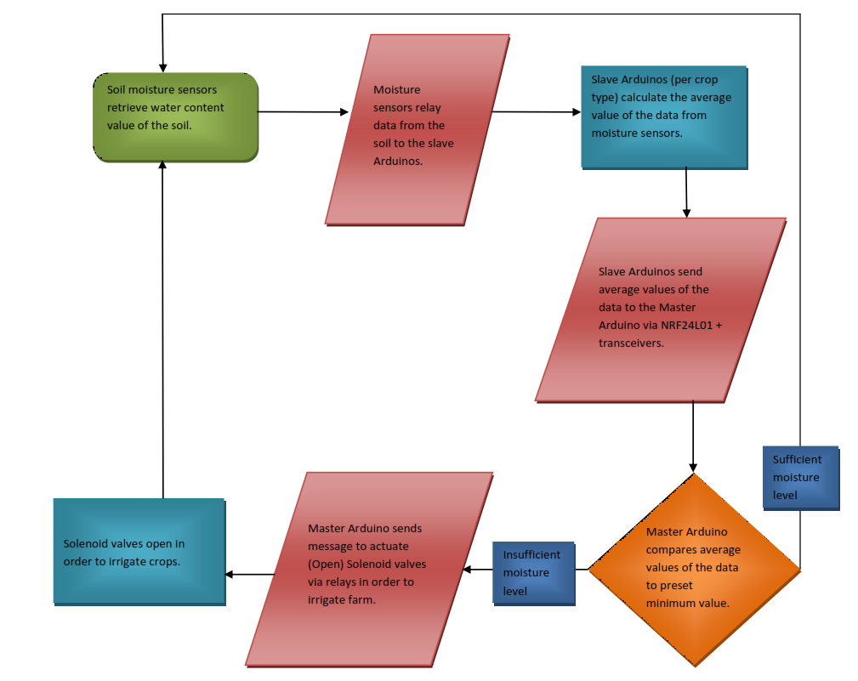

##### Figure 3.1: Flow chart of Irrigation Mechanism

## METHODS

This section brings to light the procedure in the project setup and will be explained under the different modules of the system:

Section A – Agricultural design.

Section B – Mechanical design.

Section C – Electronic design.

Section D – Software algorithm.

Section E – Power supply connection.

### Section A

This section describes the agricultural design of the system from the crop species selection to number of crops, crop water requirement calculation, tank sizing, optimum crop spacing and land sizing.

For simplicity it is mainly divided into two sections:

* Crop water requirement calculation and tank sizing.
* Crop spacing and Land Sizing.

#### Crop water requirement calculation and tank sizing

**Maize:**

Total planting in days: 20+35+40+30 = 125 days

**Crop water requirement calculation**

In this research work, three crops were focused on namely: beans, tomato and maize.

Generally, there are various ways to calculate crop water requirement. Penman-Montech equation (FAO-PM) is the best and most reliable method of Ep calculation. But it is a data intensive. Based on available information and for the purpose of simplicity, we have decided to use the Blaney-Criddle method, which is likewise accurate (*Crop water requirements Crop water requirements*, n.d.).

Blaney-Criddle method:

In 1950 Blaney-Criddle proposed an empirical formula for estimation of the potential

Eto = p(0.46Tmean + 8)

Where:

‘p’ is Mean daily percentage of annual daytime hours.

Tmean is Mean daily temperature (oC).

Eto: Reference crop evapo-transpiration

In this work, Blaney-Criddle method, was used to compute the crop water requirement. It was used because of its ease of use. It is also more comprehensive in nature.

**Mean daily percentage of annual daytime hours (p)**

The first variable in the equation was computed with the aid of the table below. The table shows the daily percentage of daytime hour per month through the span of a year. The daily percentage is calculated based on latitude location of Ota, Ogun State, Nigeria. The latitude is (7.9452oN). With that position, we can compute our daily percentage of daytime hours as:

((0.27*6) + (0.28*6))/12 = **0.275**

1.65 is the mean daily percent of annual daytime hours in a year.

Mean daily percentage (p) of annual daytime hours for different latitudes

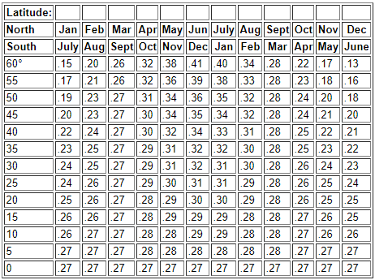

(Chapter 4 - rainfall and evapotranspiration, n.d.)

**Mean daily temperature (oC).**

The mean daily temperature for Ota, Ogun State was calculated as well.

(33.7 + 32.9 + 33.6 + 33.3 + 33.6)/5 = **33.42 oC** (Average maximum temperature in Ogun State between 2005 to 2009)

(24.2 + 24.3 + 24.5 + 23.1 + 23.6)/5 = **23.94 oC** (Average minimum temperature in Ogun State between 2005 to 2009)

Mean temperature is (33.42 + 23.94)/2 = **28.68 oC**

(Bureau & Statistics, 2012)

**Reference crop evapo-transpiration (**Eto **)**

Eto = p(0.46Tmean + 8)

Substituting the values into Eto equation, we have:

Eto = 0.275(0.46(23.94) + 8)

= 5.82mm/day

**Crop water requirement per crop (Etcrop)**

Etcrop = KC * Eto

Where KC is the crop factor.

**MAIZE**

**Etmaize** = 0.82 X 5.828mm/day

= 4.78mm/day

For complete planting time,

The overall planting season is 125 days.

i.e. 4.78 X 125 = 597.5mm through the season

**BEANS**

**Etbeans** = 0.79 X 5.828mm/day

= 4.60mm/day

For complete planting time,

The overall planting season is 125 days.

i.e. 4.60 X 90 = 414mm through the season

**TOMATO**

**Ettomato =** 0.82 X 5.828mm/day

= 4.78mm/day

For complete planting time,

The overall planting season is 95 days.

i.e. 4.78 X 104 days = 500mm through the season

(Able from doorenbos, n.d.)

**Tank sizing**

Area for maize = 1.2 m2.

Water requirement = 4.78mm/day

= 4.78 X 10-3 m/day

= 4.78 X 10-3 X 1.2

= 0.005736 m3/day.

Area for beans = 3.75 m2.

Water requirement = 4.60mm/day

= 4.60 X 10-3 m/day

= 4.60X 10-3 X 3.75

= 0.01725m3/day.

Area for tomato = 3.0 m2.

Water requirement = 5.26mm/day

= 5.26 X 10-3 m/day

= 4.78 X 10-3 X 3.0

= 0.01578 m3/day.

**Total water requirement** = 0.038766 m3/day.

= 38.766 Litres/day.

With the daily water requirement in view, a tank of 1000 liters would serve the farmland for a good while of about 25 days.

#### Crop spacing and land sizing

**Crop Spacing**

**Maize (*Zea Mays L.*)**

It can be general inferred from previously conducted research that a smaller inter-row spacing for Maize yields higher crop height and harvest index, though average grain weight, grain yield and grains/cob tend to increase with increased inter-row spacing. The maximum grain yield (5.7 t /ha) was produced when plant spacing was kept at 20 cm and nitrogen was applied at the rate of 180 kg /ha (Kaku, 2014). To this effect, we maintained a 20 cm inter-row spacing between the maize seedlings per row for both the drip irrigation experiment and control systems. It may be of importance to note that row spacing had no significant effect on the harvest and ear yield of the Hybrid breed of maize (Iptas and Acar, 1999).

**Cowpea (*Vigna Unguiculata*)**

Cowpea is an important food crop in western Saharan as well as sub-Saharan Africa. It happens to be a major source of both protein and vitamins for people, even animals. It’s leaves serve as forage and vegetables. In the case of inter-cropping with maize as is achieved in the control and experiment conditions of the project, it is recommended that Cowpea is planted with a spacing of 75cm x 50cm. (Dugje *et al.,* 2009).

**Tomato (*Solanum Lycopersicum*)**

Tomato yield and quality are influenced by fertility and separation amidst different variables. Nitrogen quantities influence numerous properties in tomato quality and yield, for example, natural product solidness, organic product measure, all out solvent solids, number of natural products per plant and attractive organic product yield we also observe that close spacing and productivity levels are essential to improve the harvest quantity and number of fruits per stand. In this regards a spacing of 30cm inter-row was selected as optimum for the crop yield (Kirimi *et al.,* 2011).

**Land Sizing**

We selected 3 different Crop Species:

Maize (*Zea Mays L.*) 20cm x 10 = 200cm

Cowpea (*Vigna unguiculata*) 50cm x 10 = 500cm

Tomatoe (*Solanum lycopersicum)* 30cm x 10 = 300cm

Total number of rows = 6.

3 rows control.

3 rows Experiment.

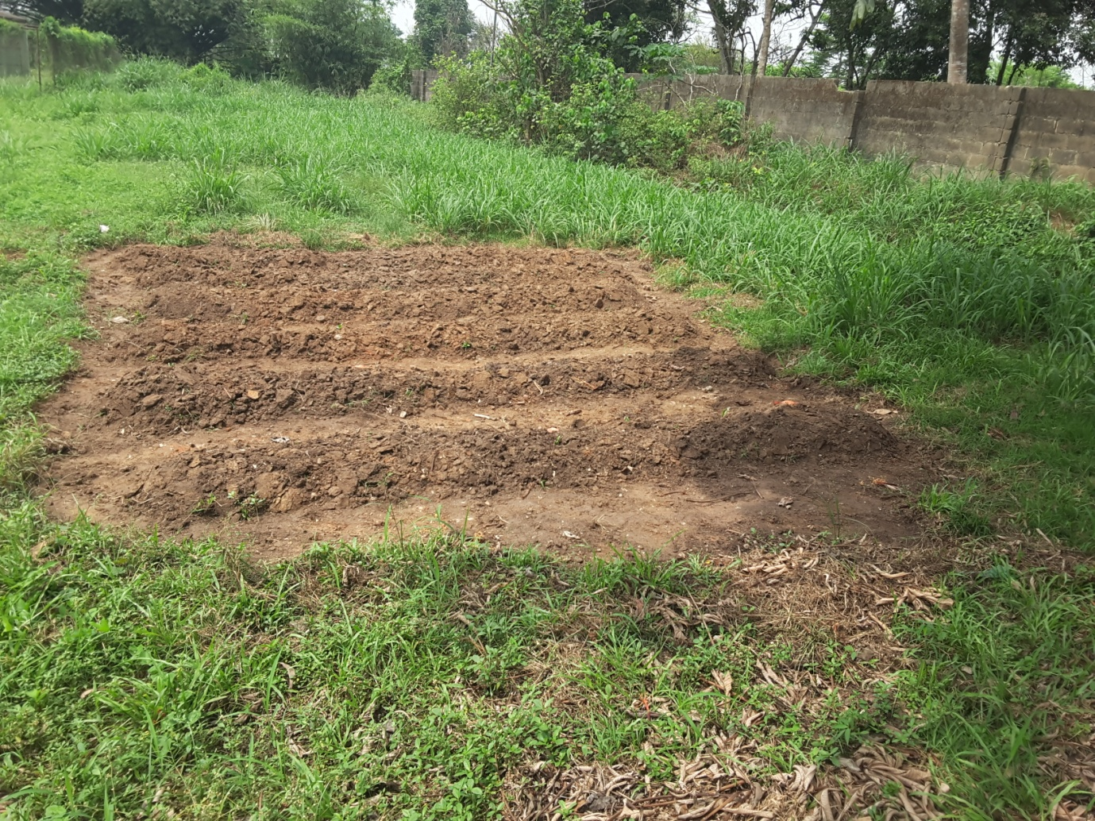

##### Figure 3.2: Farm Land

|  |  |  |  |  |
| --- | --- | --- | --- | --- |
| **Crop Species** | **Number of Crops** | **Inter-row Spacing (cm)** | **Row Length**  **(cm)** | **Row Spacing**  **(cm)** |
| EXPERIMENT | | | | |
| MAIZE | 10 | 20 | 200 | 100 |
| COWPEA | 10 | 50 | 500 | 100 |
| TOMATOE | 10 | 30 | 300 | 100 |
| CONTROL | | | | |
| MAIZE | 10 | 20 | 200 | 100 |
| COWPEA | 10 | 50 | 500 | 100 |
| TOMATOE | 10 | 30 | 300 | 100 |

Table 3.10: Crop Spacing

With an average row spacing of 1m between each row (6 rows)

Area of land required = 5m x Longest row length = 5m x 5m = 25m2 Land required.

### Section B

**Mechanical Calculation**

This shows the pressure and flow mechanics involved in the flow of water from the tank to the emitters. The results of the calculation allow us to better understand the system. It supported the decision for the application of a gravity-fed supply system without the requirement of a pump.

**Total pressure from the tank**

Total pressure from the tank at height of 2 meters is represented by

σ * g * h

where h is height and it equals 2m.

therefore, total pressure is 1000*9.81*2 = 19620N/m2

**Head Loss in pipe**

From Darcy Equation,

hf = (FlV2 /2Dg).

Where

hf  is the head loss in pipe

f is the friction factor

l is the length of pipe

V is the flow velocity

D is the diameter of pipe

G is acceleration due to gravity

Also,

f = (64/Re)

where, Re is Reynolds number.

Re = (VD/v)

Where V is the flow velocity

D is the diameter of pipe

v is kinematic viscosity

From our experiment with the flow from our tank, we have flow velocity as 1m/s

The kinematic viscosity of our fluid (water) is 8.9*10^-7 Pa

Diameter of our pipe is 0.01905m

Re = (1*0.01905)/8.9*10^-7 = 21404.494

Friction factor= (64/Re) = 64/21404.494 = 2.99*10^-3

Head loss = (2.99*10^-3 * 2 * 1)/ (0.01905*2*9.81)

Head loss = 0.01599m

**Pressure loss in pipe**

Also postulated by Darcy,

σ * g * Δh = Δp

where,

σ represents density of fluid which is 1000kg/m3

g represents acceleration due to gravity.is 9.81m/s

Δh represents head loss in pipe which is 0.01599m

Δp represents pressure loss in pipe which is unknown

Δp = 1000*0.01599*9.81= 156.86N/m2

Therefore, pressure loss in the pipe is 156.86N/m2

**Other losses**

Other losses in the system would be incurred from the solenoid valves, the drip emitters, the tees and elbows. The tees and elbows have negligible losses due to their number. There are just two tees and one elbow. Losses are reduced when those fittings are fewer in number.

### Section C

The main objective of this section is to provide a detailed insight and explanation into the electronic and control system of the mechatronics design project. The electronic component consists of:

* The Sensing Module.
* The Communication Module
* The Control Module.
* The Actuating

#### The sensing module

This unit is responsible for harvesting the moisture content of the soil at a particular time. The system consists of three sensor unit boxes for the three crop species and each sensor box consists of a network of five (5) Soil Moisture Sensors, an Arduino UNO Microcontroller (Slave Arduino) and a Nrf24L01+ transceiver. The soil moisture is measured using the Probe-type Soil Moisture Sensor. The sensor gives out a value usually between the range of 420 and 1023 based on its architecture and moisture content. This raw data is collected by the Arduino UNO. The microcontroller is then programmed to perform the following actions.

* Collect the raw data from each of the sensors; each of the five moisture sensors was inserted close to the root of the plants to obtain accurate data.
* Map the data information to a value between 0 and 100%.
* Calculate the average of the raw data from the four (4) sensors.
* Wirelessly transmit the data to the Master Arduino Mega 2568 via the Nrf24L01+ radio transmitter.

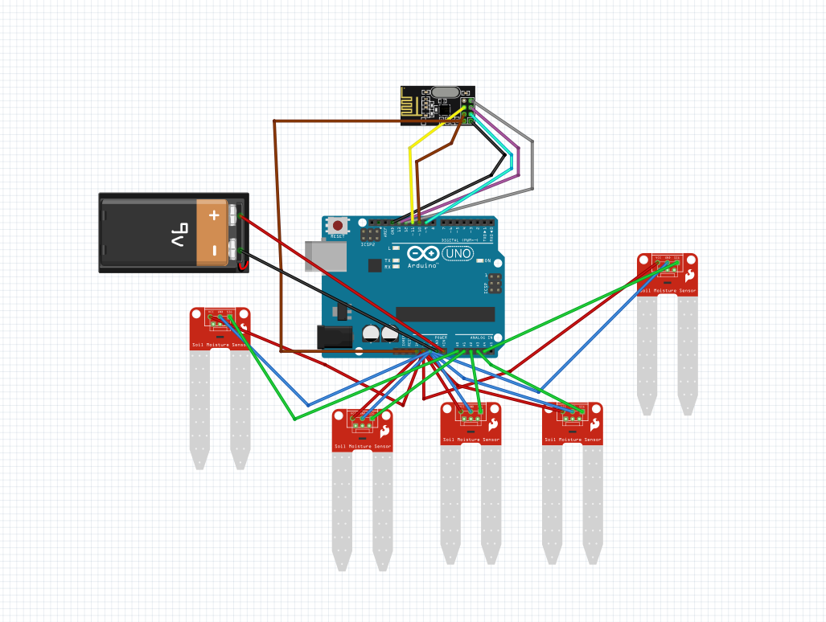

##### Figure 3.3: Sensing Unit Schematic

The Sensing Units establishes a wireless serial communication with the Master Arduino (actuating unit) via the Nrf24L01+ communication transceivers. Power is supplied to this unit by a 12 Volts D.C. battery.

#### The Communication module

The Nrf24L01+ modules (4 in number) are radio communication devices which consume low power but send data and signals at high frequencies over a relatively long range (100m). This module was chosen because of its networking capabilities and signal rate. The Master Arduino Identifies each transmitting device uniquely via a special character sent along sides the data payload.

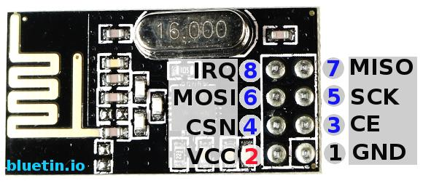

##### Figure 3.4: NRF24L01+ Module

#### The Control Module

The function of this unit is to generate a control action based on the soil moisture level. It consists mainly of an Arduino Mega 2560 microcontroller (Master Arduino), an LCD – 2x16, an Nrf24L01+ transceiver and an 8-channel relay block module all attached to and taking instructions from the Arduino Mega 2560 (master controller) . The real time soil humidity data is received by the master Arduino via the radio communicator (Nrf24L01+) module and the microcontroller is the programmed to perform the following actions:

Compare the soil humidity values with a set of ranges

A – 0 – X% (for insufficient water / dry soil),

B – X – Y% (for sufficient water / moist soil); and

C – Y – 100% (for excess water / soggy soil).

For each of the ranges of soil moisture values from each crop specie soil moisture sensor unit, a unique control action is generated.

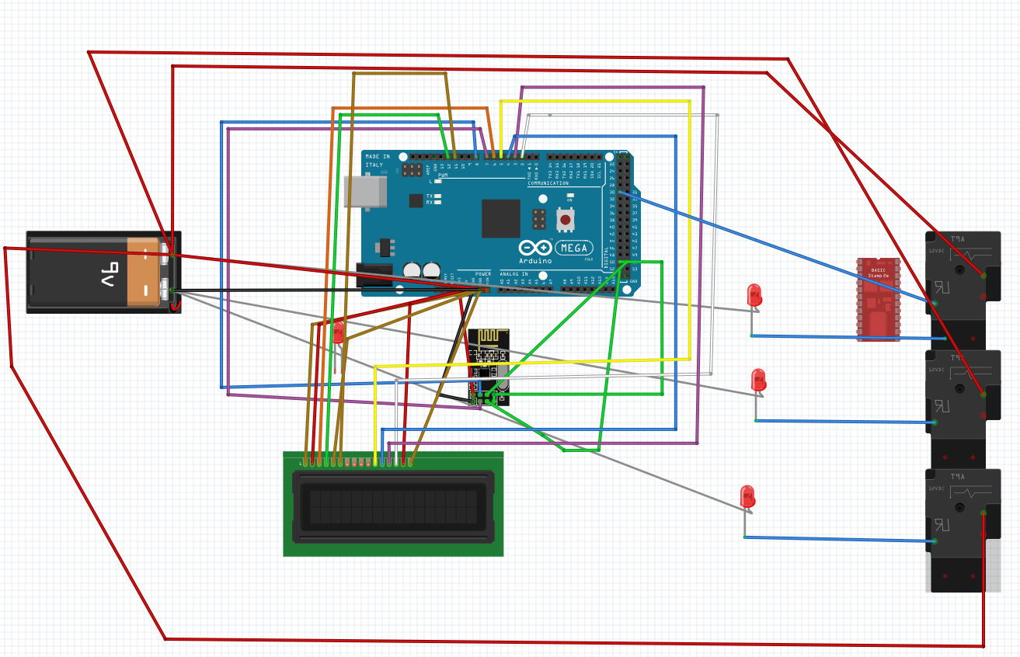

##### Figure 3.5: Control Module Schematic

This is due to the higher voltage requirement of the Solenoid valves (12V D.C.) represented by LEDs in the schematic above, the 8-channel Relay block was introduced to enable the Arduino Mega microcontroller (which can only give out a maximum of 5 Volts D.C.), control the three solenoid valves in the drip irrigation system. The following actions are taken depending on the range the received average of soil moisture falls within.

Range A – The Arduino sends a signal to open the valve along that particular soil drip line by setting the pin to the relay ‘HIGH’.

Range B – The Arduino keeps the solenoid valve is a closed position by sending a ‘LOW’ signal to the relay pin connected to the corresponding Arduino pin.

Range C – The Arduino keeps the solenoid valve is a closed position by sending a ‘LOW’ signal to the relay pin connected to the corresponding Arduino pin.

#### The Display Unit

The display unit is connected to the Arduino Mega 2560 micro-controller and is used to display the state of the solenoid valves real-time.

#### The Actuating Module

This consists simply of an Electromagnetic solenoid valve which is normally pressurized under the gravity potential of the fluid from the reservoir.

### Section D

**Software Algorithm**

Each micro-controller is programmed in the Arduino c language using the Arduino Integrated Development Environment. The C language was chosen because of its dynamic interaction with hardware, speed, memory allocation and flow algorithm.

**//Arduino Master Code**

#include <DHT.h>

#include <SPI.h> //Call SPI library so you can communicate with the nRF24L01+

#include <RF24.h> //nRF2401 libarary

#include <LiquidCrystal.h> //LCD Library

#define dht_apin A1

#define wateringTime 10000 //20 seconds

#define RELAY_ON LOW

#define RELAY_OFF HIGH

#define afterWateringWait 5000;

#define offDelayTime 2000;

LiquidCrystal lcd(12, 11, 5, 4, 3, 2);

const int pinCE = 7; //This pin is used to set the nRF24 to standby (0) or active mode (1)

const int pinCSN = 8; //This pin is used to tell the nRF24 whether the SPI communication is a //command or message to send out

RF24 radio(pinCE, pinCSN); // Declare object from nRF24 library (Create your wireless SPI)

//Create up to 3 pipe addresses P0 - P5; the "LL" is for LongLong type

const uint64_t rAddress[3] = {0x7878787878LL, 0xB3B4B5B6F1LL, 0xB3B4B5B6CDLL};

int check; //identity

int receiveDaverage; //variable to hold payload from transmitter

void CornTest();

void TomatoTest();

void CowpeaTest();

dht DHT;

void setup()

{

// put your setup code here, to run once:

Serial.begin(9600); // Initialize serial monitor

lcd.begin (16, 2); //set the LCD's number of columns and rows

pinMode (28,OUTPUT);//set pin 28 as output

pinMode (30,OUTPUT);

pinMode (32,OUTPUT);

lcd.setCursor (0,0);

lcd.print("MECHATRONICS IN"); //print on LCD display

lcd.setCursor(0,1);

lcd.print("AGRICULTURE");

delay(3000);

lcd.clear();

lcd.setCursor(0,0);

lcd.print("A FOCUS ON");

lcd.setCursor(0,1);

lcd.print("IRRIGATION");

delay(offDelayTime);

lcd.clear();

lcd.print("Project by:");

lcd.setCursor(0,1);

lcd.print("Presh,Daran,Fame");

delay(3000);

lcd.clear();

lcd.print("Supervisor");

lcd.setCursor(0,1);

lcd.print("Prof. Bolu");

delay(3000);

lcd.clear();

radio.begin(); //Start the nRF24 module

digitalWrite(28, RELAY_OFF); // Set pin 28 as high initially

digitalWrite(30, RELAY_OFF);

digitalWrite(32, RELAY_OFF);

// Open up to three pipes for PRX to receive data

radio.openReadingPipe(0,rAddress[0]);

radio.openReadingPipe(1,rAddress[1]);

radio.openReadingPipe(2,rAddress[2]);

radio.startListening(); // Start listening for messages

}

void loop()

{

// put your main code here, to run repeatedly:

lcd.setCursor(0,0);

lcd.print("receiving");

lcd.setCursor(0,1);

lcd.print("data...");

delay(offDelayTime);

DHT.read11(dht_apin);

lcd.setCursor(0,0);

lcd.print("H = ");

lcd.print(DHT.humidity);

lcd.print("% ");

lcd.print("T = ");

lcd.print(DHT.temperature);

lcd.print("C ");

delay(offDelayTime);

lcd.clear();

while (radio.available()) //Check if received data

{

radio.read(&receiveDaverage, 1);//reads the received average from the transmitting micro controller into the 'receiveDaverage' variable.

radio.read(&check, 1);//reads the received identity value from the transmitting micro controller into the 'check' variable.

if (check == 2)//arduino Identity conditional check

{

TomatoTest();

}

if (check == 1)

{

CornTest();

}

if (check ==3)

{

CowpeaTest()

}

}

//Function definitions

void tomatoTest()

{

if (receiveDaverage<20) //for dry soil

{

Serial.print("Dry soil, Valve 2: Open");

lcd.setCursor(0,0);//sets cursor position

lcd.print("DRY SOIL: ");//prints

lcd.print(receiveDaverage);

lcd.print("%");

lcd.setCursor(0,1);

lcd.print("VALVE 2: OPEN");

digitalWrite(28, RELAY_ON);//sets pin at 28 high to open valve

delay (wateringTime);//waters for 'wateringTime value'

digitalWrite(28, RELAY_OFF);

delay(afterWateringWait);

lcd.clear();

}

else if (receiveDaverage>= 20 && receiveDaverage<=50) //for Moist Soil

{

Serial.print("Moist soil, Valve 2: Closed");

lcd.setCursor(0,0);//sets cursor position

lcd.print("MOIST SOIL: ");//prints

lcd.print(receiveDaverage);

lcd.print("%");

lcd.setCursor(0,1);

digitalWrite(28,RELAY_OFF);//sets pin at 28 to low, keeping valve closed

delay(offDelayTime);//delay for 2 seconds

lcd.clear();

}

else if (receiveDaverage > 50) // For Soggy soil

{

Serial.print("soggy soil, Valve 2: Closed");

}

lcd.setCursor(0,0);

lcd.print("SOGGY SOIL: ");

lcd.print(receiveDaverage);

lcd.print("%");

lcd.setCursor(0,1);

lcd.print("VALVE 2: CLOSED");

digitalWrite(28,RELAY_OFF);

delay(offDelayTime);

lcd.clear();

}

}

void CornTest()

{

if (receiveDaverage<40) // for dry soil

{

Serial.print("DRY Soil Valve 1 Open");

lcd.setCursor(0,0);

lcd.print("DRY SOIL: ");

lcd.print(receiveDaverage);

lcd.print("%");

lcd.setCursor(0,1);

lcd.print("VALVE 1: OPEN");

digitalWrite(30, RELAY_ON);

delay (wateringTime);

digitalWrite(30, RELAY_OFF);

delay(afterWateringWait);

}

else if (receiveDaverage>= 40 && receiveDaverage<=70) //for Moist Soil

{

Serial.print("Moist soil, Valve 1: Closed");

lcd.setCursor(0,0);

lcd.print("MOIST SOIL: ");

lcd.print(receiveDaverage);

lcd.print("%");

lcd.setCursor(0,1);

lcd.print("VALVE 1: CLOSED");

digitalWrite(30, RELAY_OFF);

delay(offDelayTime);

lcd.clear();

}

else if (receiveDaverage > 70) // For Soggy soil

{ Serial.print("soggy soil, Valve 1: Closed");

lcd.setCursor(0,0);

lcd.print("SOGGY SOIL: ");

lcd.print(receiveDaverage);

lcd.print("%");

lcd.setCursor(0,1);

digitalWrite(30,RELAY_OFF);

lcd.print("VALVE 1: CLOSED");

lcd.setCursor(0,1);

delay(offDelayTime);

lcd.clear();

}

}

void cowpeaTest()

{

if (receiveDaverage< 60)

{

Serial.print("DRY Soil Valve 3: Open");

lcd.setCursor(0,0);

lcd.print("DRY SOIL: ");

lcd.print(receiveDaverage);

lcd.print("%");

lcd.setCursor(0,1);

lcd.print("VALVE 3: OPEN");

digitalWrite(32, RELAY_ON);

delay (wateringTime);

digitalWrite(32, RELAY_OFF);

delay(afterWateringWait);

}

else if (receiveDaverage>= 60 && receiveDaverage<=80) //for Moist Soil

{ Serial.print("Moist soil, Valve 3: Closed");

lcd.setCursor(0,0);

lcd.print("MOIST SOIL: ");

lcd.print(receiveDaverage);

lcd.print("%");

lcd.setCursor(0,1);

lcd.print("VALVE 3: CLOSED");

digitalWrite(32,RELAY_OFF);

lcd.setCursor(0,1);

delay(offDelayTime);

lcd.clear();

}

else if (receiveDaverage > 80) // For Soggy soil

{

Serial.print("soggy soil, Valve 3: Closed");

lcd.setCursor(0,0);

lcd.print("SOGGY SOIL: ");

lcd.print(receiveDaverage);

lcd.print("%8");

lcd.setCursor(0,1);

lcd.print("VALVE 3: CLOSED");

digitalWrite(32, RELAY_OFF);

lcd.setCursor(0,1);

delay(offDelayTime);

lcd.clear();

}

}

**//Arduino Slave Code (Tomatoe Sample)**

#include <SPI.h> //Call SPI library so you can communicate with the nRF24L01+

#include <nRF24L01.h> //nRF2401 libarary found at https://github.com/tmrh20/RF24/

#include <RF24.h> //nRF2401 libarary found at https://github.com/tmrh20/RF24/

#define potPin A0

#define potPin1 A1

#define potPin2 A2

#define potPin3 A3

#define potPin4 A4

const int numReadings = 5; // how many readings to average

const int check = 2;// use this for transmitting a special Identification character

int sensorValue = 0;// value read from the Soil Moisture

int sensorValue1 = 0;// value read from the Soil Moisture

int sensorValue2 = 0;// value read from the Soil Moisture

int sensorValue3 = 0;// value read from the Soil Moisture

int sensorValue4 = 0;// value read from the Soil Moisture

RF24 radio(7, 8); // CE, CSN

#define WHICH_NODE 2 // must be a number from 1 - 6 identifying the PTX node

const uint64_t wAddress[] = {0x7878787878LL, 0xB3B4B5B6F1LL, 0xB3B4B5B6CDLL};

const uint64_t PTXpipe = wAddress[ WHICH_NODE - 0]; // Pulls the address from the above array for this node's pipe

byte counter = 1; //used to count the packets sent

float averageT;

float average (int sensorValue, int sensorValue1 ,int sensorValue2 ,int sensorValue3, int sensorValue4)

{

float value = (sensorValue + sensorValue1 + sensorValue2 + sensorValue3 + sensorValue4)/5;

return(value);

}

void setup() {

// put your setup code here, to run once:

Serial.begin(9600);

pinMode( potPin, INPUT);

pinMode( potPin1, INPUT);

pinMode( potPin2, INPUT);

pinMode( potPin3, INPUT);

pinMode( potPin4, INPUT);

radio.begin(); //Start the nRF24 module

radio.setPALevel(RF24_PA_LOW); // "short range setting" - increase if you want more range AND have a good power supply

radio.setChannel(108); // the higher channels tend to be more "open"

radio.openReadingPipe(0, PTXpipe); //open data transfer pipe

radio.stopListening();//go into transmit mode

}

void loop()

{ // put your main code here, to run repeatedly:

sensorValue = analogRead(potPin);// read the analog in values

sensorValue = map(sensorValue, 1023, 416, 0, 100);//map or caliberate the values to a percentage form between 0 and 100

sensorValue = constrain(sensorValue, 0, 100);

sensorValue1 = analogRead(potPin1);

sensorValue1 = map(sensorValue1, 1023, 416, 0, 100);

sensorValue1 = constrain(sensorValue1, 0, 100);// in case the sensor value is outside the range seen during calibration

sensorValue2 = analogRead(potPin2);

sensorValue2 = map(sensorValue2, 1023, 416, 0, 100);

sensorValue2 = constrain(sensorValue2, 0, 100);

sensorValue3 = analogRead(potPin3);

sensorValue3 = map(sensorValue3, 1023, 416, 0, 100);

sensorValue3 = constrain(sensorValue3, 0, 100);

sensorValue4 = analogRead(potPin4);

sensorValue4 = map(sensorValue4, 1023, 416, 0, 100);

sensorValue4 = constrain(sensorValue4, 0, 100);

//calculate the average of the moisture values.

averageT = (sensorValue + sensorValue1 + sensorValue2 + sensorValue3 + sensorValue4)/numReadings;

radio.write(&averageT, sizeof(averageT));

radio.write(&check, sizeof(check));

Serial.println(averageT);

Serial.println(check);

delay(63); // delay for 63 milli seconds.

}

### Section E

**Power Requirements**

The system is powered via a combination of an 18V solar panel module and a 40AHr, 12V battery system. The solar panel charges and powers the system during the day and the battery pack takes over at night to recharge the following day in sunlight via the solar panel and solar charge controller.

|  |  |  |  |  |  |
| --- | --- | --- | --- | --- | --- |
| Component | Quantity | Current Rating (A) | Total  Current (A) | Time of Operation per day (Hours) | Energy Requirement (Ah) |
| Arduino UNO | 3 | 0.2 | 0.6 | 24 | 14.4 |
| Arduino Mega | 1 | 0.5 | 0.5 | 24 | 12 |
| Solenoid Valves | 3 | 1 | 3 | 1 | 3 |

Total 29.4

Using an approximated value of 30Ah; Minimum battery size required = 30*2 = 60Ah

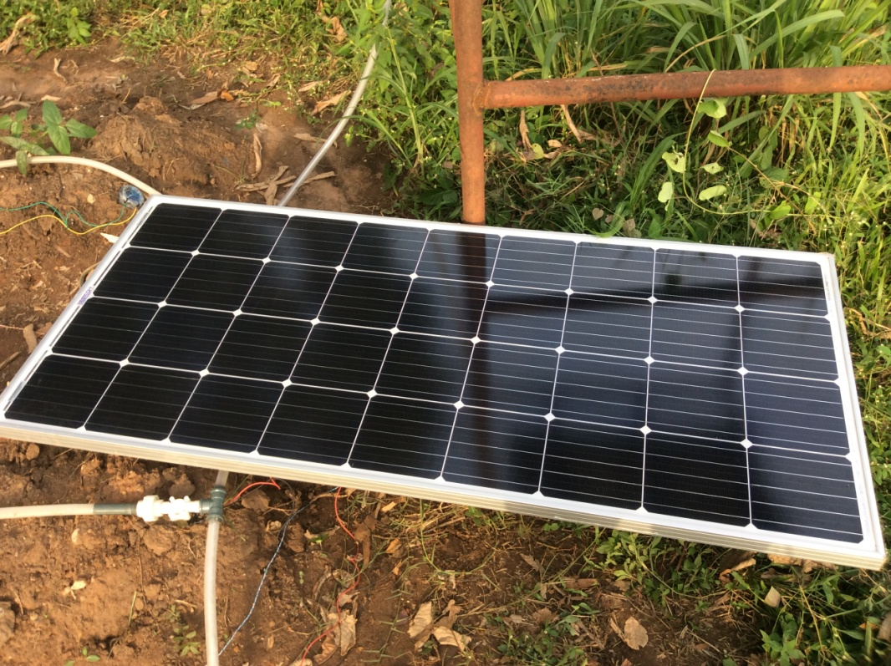

##### Figure 3.6: Power supply module

### Conclusion

The final step was to integrate all the sections and modules to function as a single system, achieving synergy. The system was set up and implemented in an area of land located close to the foundry building.

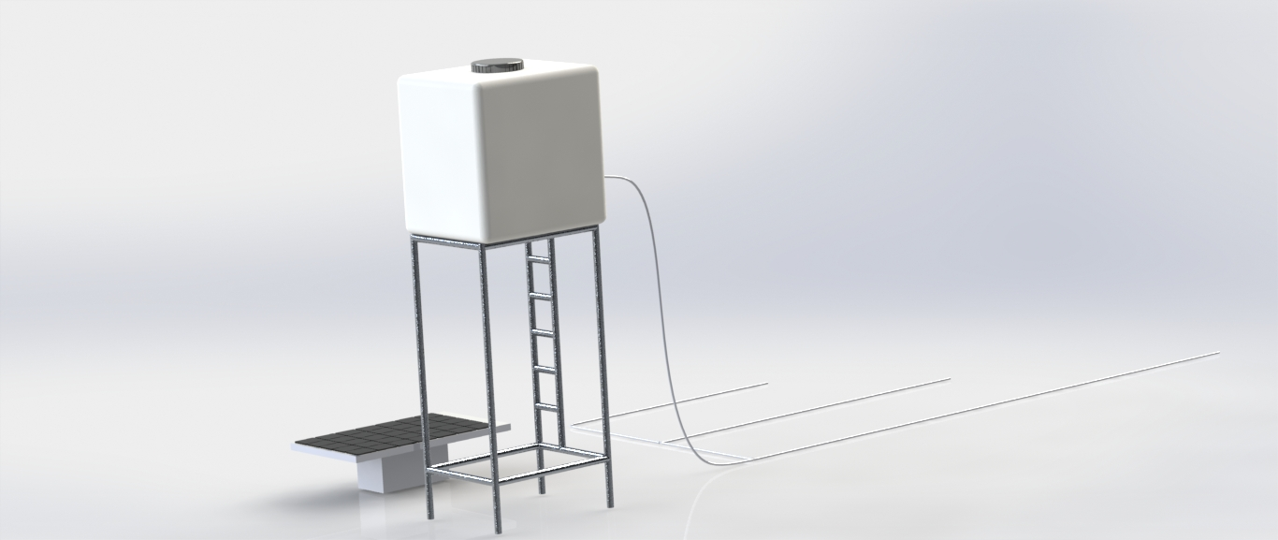

##### Figure 3.7: 3D model of the system

# CHAPTER FOUR

# RESULTS & DISCUSSION

## INTRODUCTION

This chapter presents the results of the design work and the discussion of the overall working of the designed and constructed system.

## RESULTS

This section presents the pictorial results of the design work.

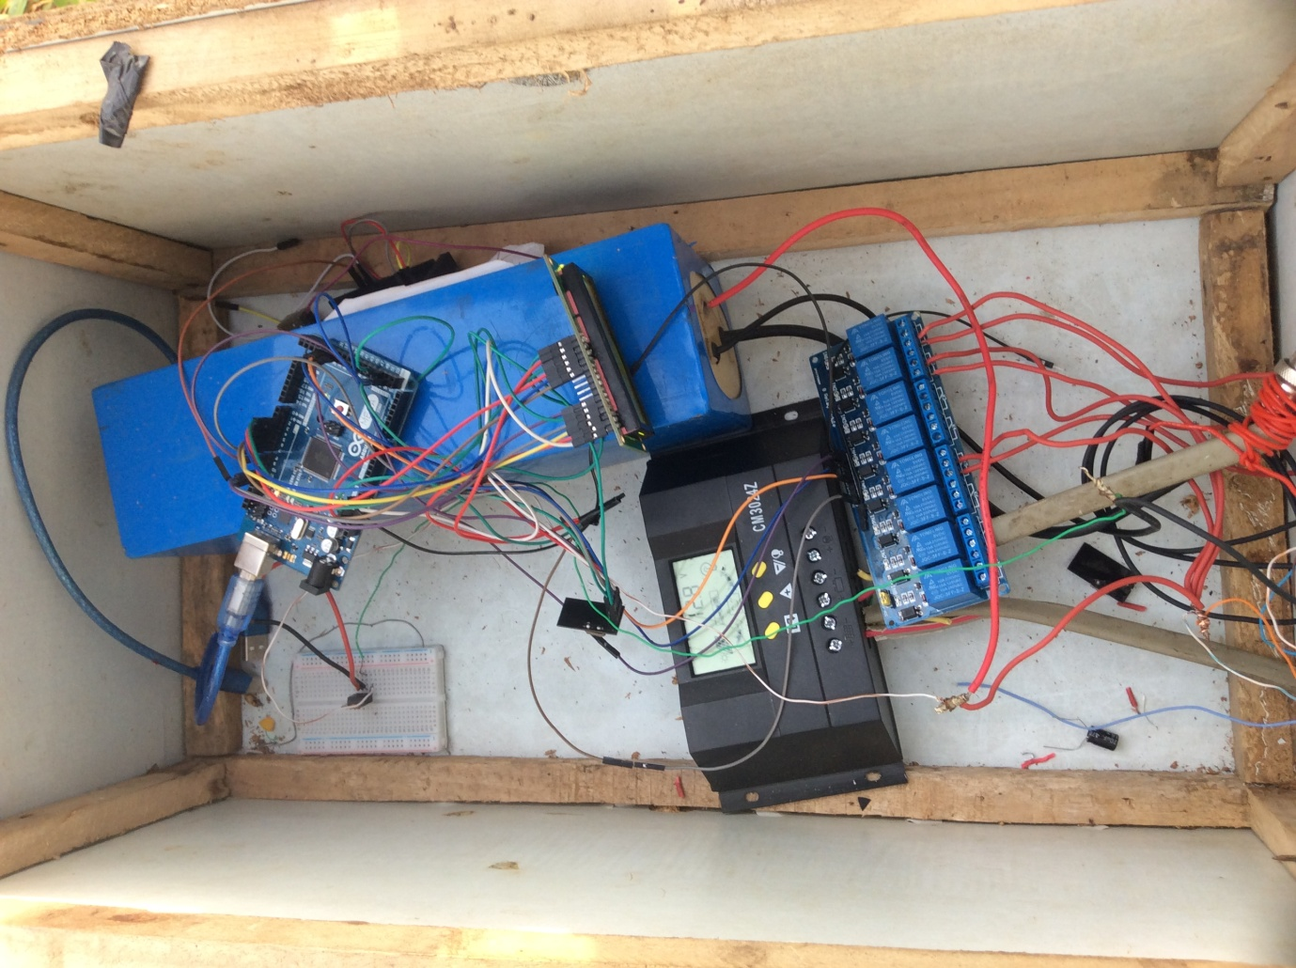

##### Figure 4.1: Brain box of the system

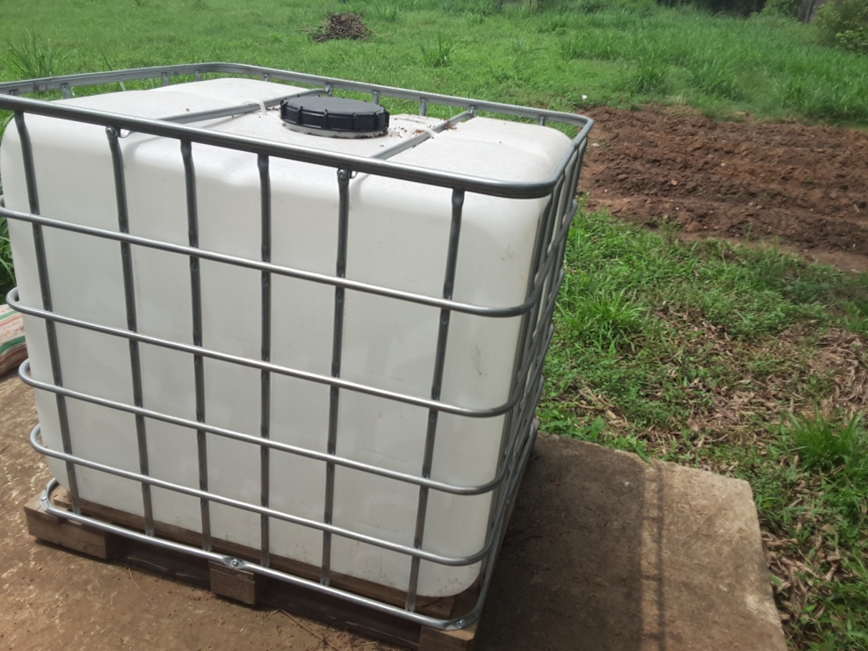

##### Figure 4.2: Water Storage Tank

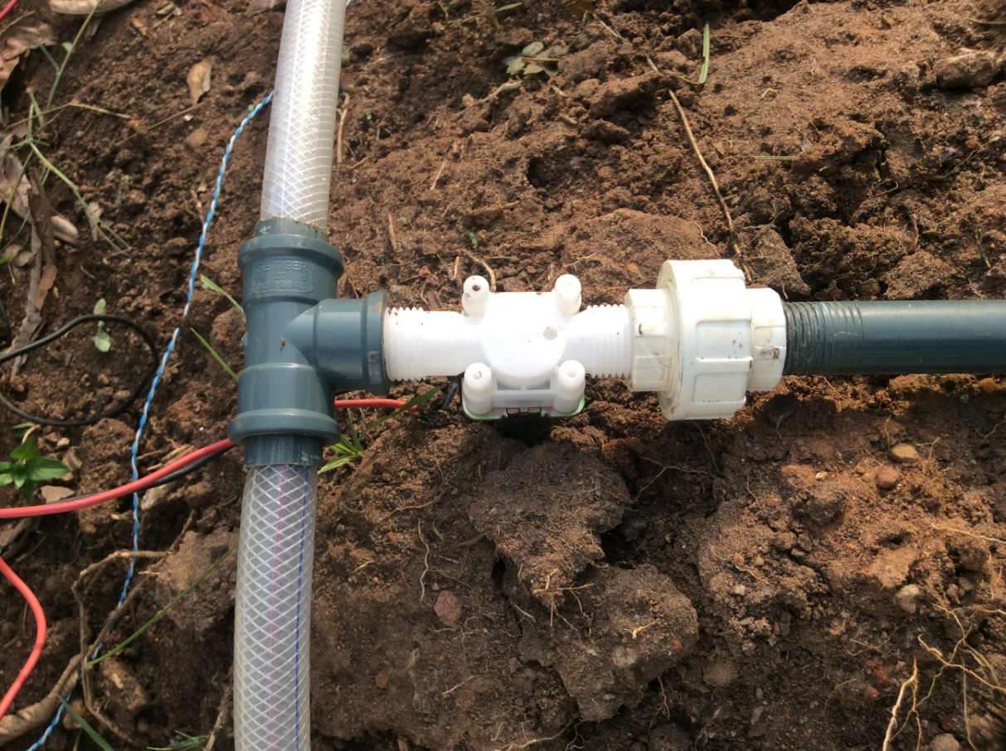

##### Figure 4.3: Solenoid Valve (Installed)

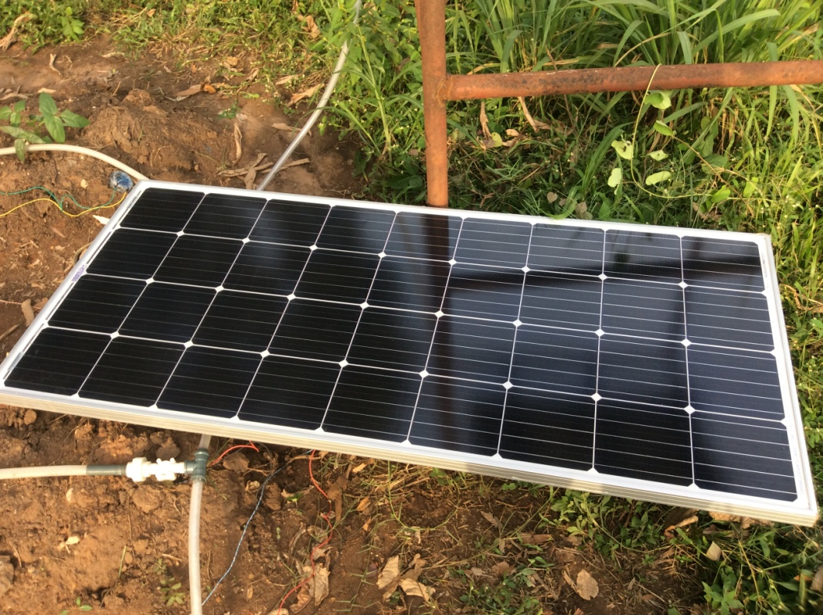

##### Figure 4.4: Solar Panel (Installed)

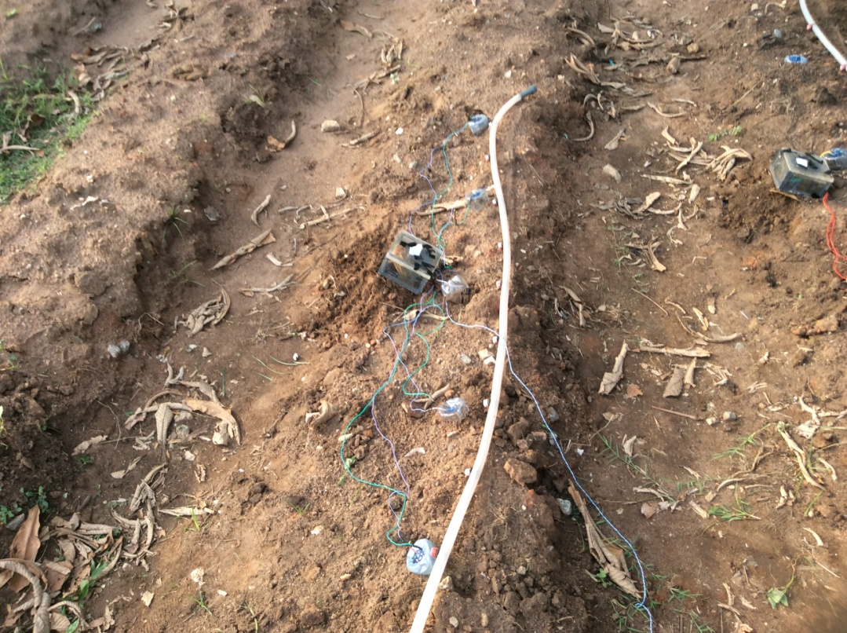

##### Figure 4.5: Sensor box with distributed sensors

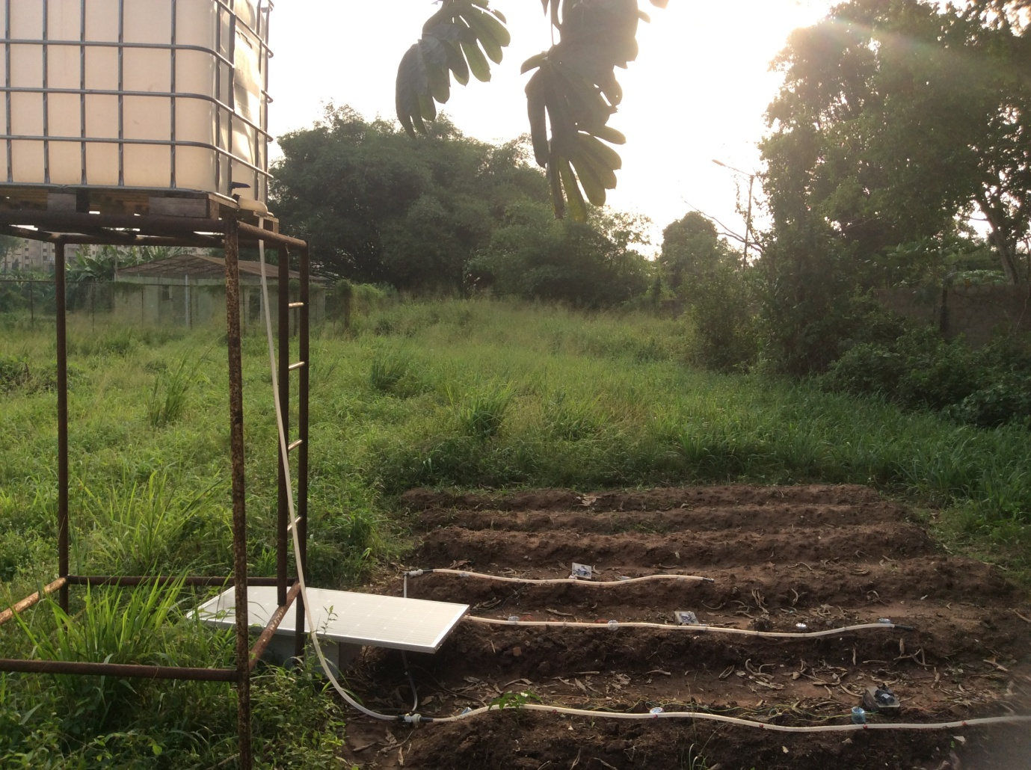

##### Figure 4.6: Automated irrigation system

## DISCUSSION

The automated drip irrigation system as seen above was constructed to operate based on the soil moisture readings gotten by soil moisture sensors. These readings are analyzed and acted upon based on the software (code) loaded onto the microcontrollers. In this system, a microcontroller is assigned each row of crops. Each microcontroller obtains the mean soil moisture from an array of moisture sensors spread across the row. The resultant reading is wirelessly transmitted to and receiver by another microcontroller with the aid of ***nRF24L01*** transceivers. This microcontroller programmed to maintain a predetermined soil moisture range as required for each type of crop. In this project, for example:

* Cowpea – 60% - 80%
* Corn – 40% - 70%
* Tomato – 20% - 50%

When the soil moisture falls below the accepted ranges, the corresponding solenoid valve is actuated to allow for irrigation of the crops.

The setting up of the automated irrigation system is quite simple. The tank and pipe layout are first constructed for proper flow of water to the crops. The water pressure can be obtained with the aid of gravity and tank head as done in this project, or a water pump can be implemented if greater pressure is required in the system. This construction will create the structure for the irrigation system and enable for proper installation of each array of soil moisture sensors and their respective microcontrollers. The solenoid valves are connected to the valve-actuating microcontroller in the brain box of the system. The brain box consists of a battery (charged by a solar panel), relay system and the valve-actuating microcontroller.

The system is designed to run automatically with little or no maintenance requirements, the user is required only to ensure that the irrigation water tank is not empty.

# CHAPTER FIVE

# CONCLUSION AND RECOMMENDATIONS

## INTRODUCTION

Water is very important and necessary for the survival of all living things on earth. Most of the fresh water on earth is used in agriculture for irrigation. Drip method is a method of irrigation used in conserving water usage in agriculture. In drip irrigation process, water is distributed continuously to the crop roots drop by drop. This is essential because it reduces water use and ensures the survival of the crops and avoids damage to crops due to excessive irrigation. A microcontroller-based drip irrigation mechanism has been designed to efficiently run all the activities involved in a drip irrigation system. Water is supplied to the crops in the right quantity and at the required time. This improves crop development and helps in time and cost saving (Prathyusha and Suman, 2012).

## CONCLUSION

From the results of our design we were able to apply mechatronics in agriculture by achieving an automated irrigation system. The system which was designed and developed by integrating several hardware and software features has been tested successfully. The designed system was able to accomplish the following:

* Determine when exactly the soil of each crop needs water.
* Wirelessly communicate the moisture state of the soil of the different crops to the control module.
* Deliver a controlled amount of water to the root zone of the crops based on the soil moisture state.
* Able to run 24/7 on renewable solar energy.

## RECOMMENDATIONS

## Based on the outcome of this project, further work put into consideration the following recommendations:

* The system should be simulated on a much larger scale such as an industrial farm, in order to test for variances not captured by the small-scale test carried out in this project.
* A pump can be integrated to add extra pressure in the water delivery system for large scale distribution.
* Soil moisture sensors with better accuracy should be used to avoid fluctuations of reading generated and for increased durability.
* Soil moisture sensors with water protection should be used.
* Wireless standalone soil moisture sensors can be used to reduce the number of physical connections in the system making it more seamless.
* Internet of Things (IOT) should be used to have unlimited locus of control for the system.
* The system can be designed such that status of the water tank can be monitored electrically.

# BIBLIOGRAPHY

Abbas, A. (2011). *Introduction to Agriculture*. Peshawar Pakistan: The University of Agriculture.

Abdelkerim, A. I., Eusuf, M. M. R. S., Salami, M. J. E., Aibinu, A., & Eusuf, M. A. (2013). Development of solar powered irrigation system. *IOP Conference Series: Materials Science and Engineering*, *53*(1). https://doi.org/10.1088/1757-899X/53/1/012005

AFED. (2008). *Water Efficiency in Agriculture*. Retrieved from <http://www.afedonline.org/water%20efficiency%20manual/PDF/6Chapter%205_Agriculture.pdf>

Agbetuyi, A. F., Orovwode, H. E., Awelewa, A. A., Wara, S. ., & Oyediran, T. (2016). Design and implementation of an automatic irrigation system based on monitoring soil moisture. *Journal of Electrical Engineering*, *3*(10), 159–162. https://doi.org/10.17148/IARJSET.2016.31030

Amrutha, A., Lekha, R., & Sreedevi, A. (2016). Automatic soil nutrient detection and fertilizer dispensary system. In *Robotics: Current Trends and Future Challenges (RCTFC), International Conference on* (pp. 1-5). IEEE.

Angal, S. (2017). Raspberry pi and Arduino based automated irrigation system. *International Journal of Science and Research (IJSR)*, *5*(7), 1145–1148.

Åstrand, B., & Baerveldt, A. J. (2002). An agricultural mobile robot with vision-based perception for mechanical weed control. *Autonomous robots*, *13*(1), 21-35.

Awati, J. S., & Patil, V. S. (2012). Automatic irrigation control by using wireless sensor networks, *1*(6).

Bjorneberg, D. L. (2013). Irrigation methods. *Earth Systems and Environmental Sciences*. https://doi.org/10.1016/B978-0-12-409548-9.05195-2

Bonifaz, J., Happy, S., Linhares, B., & Velasco, J. (2009). Mechatronics in the evolution of our agriculture, 1–7.

Burney, J., Woltering, L., Burke, M., Naylor, R., & Pasternak, D. (2009). Solar-powered drip irrigation enhances food security in the Sudano – Sahel. <https://doi.org/10.1073/pnas.0909678107>

Chang, C. L., & Lin, K. M. (2018). Smart agricultural machine with a computer vision-based weeding and variable-rate irrigation scheme. *Robotics*, *7*(3), 38.

Deo Kumar, B., Srivastava, P., Agrawal, R., & Tiwari, V. (2017). Microcontroller based automatic plant irrigation system. *International Research Journal of Engineering and Technology*, 2395–56.

Dieterle, W. (2004). Mechatronic systems: industrial applications and modern design methodologies. *IFAC Proceedings Volumes*, *37*(14), 1–5. https://doi.org/10.1016/S1474-6670(17)31071-6

Duckett, T., Pearson, S., Blackmore, S., & Grieve, B. (2018). Agricultural robotics: the future of robotic agriculture. *Arxiv preprint arxiv:1806.06762*.

Dugje, I. Y., Omoigui, L. O., Ekeleme, F., Kamara, A. Y., & Ajeigbe, H. (2009). Farmers’ guide to cowpea production in West Africa. *IITA, Ibadan, Nigeria*, *20*, 12-14.

Erdélyi, V., & Jánosi, L. (2017). Mechatronics in Agriculture. *Scientific Bulletin Series C: Fascicle Mechanics, Tribology, Machine Manufacturing Technology*, *31*, 31-35.

Fisher, D. K., & Kebede, H. (2010). A low-cost microcontroller-based system to monitor crop temperature and water status. *Computers and Electronics in Agriculture*, *74*(1), 168–173. https://doi.org/10.1016/j.compag.2010.07.006

Gore, T. H., Kote, M. P., Varpe, P. B., & Jagtap, M. T. (2016). Crop monitoring analysis and controlling system, *6*(2), 138–141.

Grau, J. B., Antón, J. M., Packianather, M. S., Ermolov, I., Aphanasiev, R., & Cisneros, J. M. (2009). Sustainable agriculture using an intelligent mechatronic system, (1), 3452–3457. https://doi.org/10.1109/IECON.2009.5415192

Greentumble Editorial Team. (2016). *Ways to Reduce Water Consumption on Farms.* Retrieved from <https://greentumble.com/ways-to-reduce-water-consumption-on-farms/>

Hessel, L., & Bar-On, D. (2003). *U.S. Patent No. 6,508,033*. Washington, DC: U.S. Patent and Trademark Office.

Hochmuth, G. (2017). *Chapter 5: Drip Irrigation*. *A Guide to the Manufacture, Performance, and Potential of Plastics in Agriculture*. Elsevier Ltd. https://doi.org/10.1016/B978-0-08-102170-5.00005-1

Imadi, S. R., Shazadi, K., Gul, A., & Hakeem, K. R. (2016). Sustainable crop production system. In *Plant, Soil and Microbes*, 103-116.

Imam, A. S., & Bicker, R. (n.d.). Establishing mechatronics engineering education in Nigeria. 1–13.

Iptas, S., & Acar, A. A. (2006). Effects of hybrid and row spacing on maize forage yield and quality. *Plant Soil and Environment*, *52*(11), 515.

Jain, R., Kulkarni, S., Shaikh, A., & Sood, A. (2016). Automatic irrigation system for agriculture field using wireless sensor network (WSN). *International Research Journal of Engineering and Technology (IRJET)*, *3*(04).

Kaku, K. S. (2014). Effect of different levels of nitrogen and intra-row plant intra-row plant spacing on yield and yield components of maize.

Khatri, K. L., & Smith, R. (2011). Surface irrigation for energy and water use efficiency. In *Proceedings of Irrigation 2011-New Horizons, Fresh Ideas Regional Conference and Exhibition*. Irrigation Australia Ltd, 20–21.

Kizito, F., Campbell, C. S., Campbell, G. S., Cobos, D. R., Teare, B. L., Carter, B., & Hopmans, J. W. (2008). Frequency, electrical conductivity and temperature analysis of a low-cost capacitance soil moisture sensor. *Journal of Hydrology*, *352*(3–4), 367–378. <https://doi.org/10.1016/j.jhydrol.2008.01.021>

Koech, R., Smith, R., & Gillies, M. (2010). Automation and control in surface irrigation systems: current status and expected future trends. In *Proceedings of the 2010 Southern Region Engineering Conference (SREC 2010)*, 11-17.

Kumar, D. S., & Palanisami, K. (2010). Impact of Drip Irrigation on Farming System: Evidence from Southern India. *Agricultural Economics Research Review*, *23*(December), 265–272. Retrieved from https://ageconsearch.umn.edu/bitstream/97154/2/7-D-Suresh.pdf

Kumar, G. (2014). Research paper on water irrigation by using wireless sensor network. *International Journal of Scientific Research Engineering & Technology (IJSRET)*, 3–4.

Kumar, K. M., & Ravi, S. K. (2016). Automation of irrigation system based on Wi-Fi technology and IOT. *Indian Journal of Science and Technology*, *9*(17). https://doi.org/10.17485/ijst/2016/v9i17/93048

Leroux, M. F., & Raghavan, G. V. (2005). Design of an automated irrigation system. *McGill University Canada, research paper*.

Muñoz-Carpena, R., & Dukes, M. D. (2015). Automatic irrigation based on soil moisture for vegetable crops. *Nutrient Management of Vegetable and Row Crops Handbook*, *173*.

Nääs, I. D. A. (2002). Applications of Mechatronics to Animal Production. *Agricultural Engineering International:The CIGR Journal of Scientific Research and Development.*, *IV*.

National Bank for Agriculture and Rural Development. (2007). *Model Bankable Projects: Sprinkler irrigation.* Retrieved from http://farmextensionmanager.com/English/ Agribusiness%20oppertunities/Agri%20engineering%20sector/Sprinkler.htm

National Bureau of Statistics. (2012). Annual abstract of statistics. *Federal Republic of Nigeria National Bureau of Statistics.*

Navarro-Hellín, H., Martínez-del-Rincon, J., Domingo-Miguel, R., Soto-Valles, F., & Torres-Sánchez, R. (2016). A decision support system for managing irrigation in agriculture. *Computers and Electronics in Agriculture*, *124*, 121–131. https://doi.org/10.1016/j.compag.2016.04.003

Njoroge, P. K. (2008). *Microcontroller-Based Irrigation System* (B.Sc. Project). University of Nairobi, Nairobi, Kenya.

Okoye, F. A., Orji, E. Z., & Ozor, G. O. (2018). Using Arduino Based Automatic Irrigation System to Determine Irrigation Time for Different Soil Types in Nigeria, 42–47. https://doi.org/10.17148/IJARCCE.2018.777

Oseko, F. O. (2016). *Design of sprinkler irrigation system for a farm in menara* (B.Sc. Project)*.* University of Nairobi, Nairobi, Kenya.

Pasha, S., & Yogesha, B. (2014). Microcontroller based automated irrigation system. *The International Journal Of Engineering And Science*, *(IJES), Volume3*, (7), 06-09.

Patidar, M., & Belsare, S. S. (2015). Design and implementation of automatic irrigation system using arm7. *IOSR Journal of Computer Engineering Ver. VII*, *17*(3), 2278–2661. <https://doi.org/10.9790/0661-17377991>

Phocaides, A. (2007). *Handbook on pressurized irrigation techniques*. Food & Agriculture Organisation.

Prathyusha, K., & Suman, M. C. (2012). Design of embedded systems for the automation of drip irrigation, *1*(2), 254–258.

Rajpal, A., Jain, S., Khare, N., & Shukla, A. K. (2011). Microcontroller-based automatic irrigation system with moisture sensors, (Icse), 94–96.

Raju, B. V. (2017). An automatic form monitoring system using arduino and wireless sensor networks. *International Journal of Innovative Research in Science, Engineering and Technology(IJIRSET)*, *6*(7), 14777–14785.

Ramli, N. L., Mohd Yamin, N., Ab Ghani, S., Saad, N. M., & Md Sharif, S. A. (2015). Implementation of passive infrared sensor in street lighting automation system. *ARPN Journal of Engineering and Applied Sciences*, *10*(22), 17120–17126. <https://doi.org/10.1149/2.1151509jes>

Ray, P. P. (2016). Internet of things cloud enabled MISSENARD index measurement for indoor occupants. *Measurement*, *92*, 157-165.

Sathyapriya, E., Naveenkumar, M. R., & Dhivya, V. (2017). An empirical study on drip irrigation. *National conference on Micro Irrigation, At TNAU, Coimbatore.*

Sigrimis, N., Antsaklis, P., & Groumpos, P. P. (2001). Advances in control of agriculture and the environment. *IEEE Control Systems, 21(5),* 8-12.

Song, Y., Sun, H., Li, M., & Zhang, Q. (2015). Technology application of smart spray in agriculture: A review. *Intelligent Automation & Soft Computing*, *21*(3), 319-333.

Shankar, M. S., Ramanjaneyulu, A., & Neelima, T. (2015). Sprinkler irrigation–an asset in water scarce and undulating areas.

Sharma, R. K., & Singh, S. (2008). Integrated water management, irrigation methods. *National Science Digital Library*. Retrieved from <http://nsdl.niscair.res.in/jspui/handle/123456789/552>

Smith, M., Muñoz, G., & Sanz Alvarez, J. (2014). Irrigation Techniques for Small-scale Farmers: Key Practices for DRR Implementers.

Stentz, A., Dima, C., Wellington, C., Herman, H., & Stager, D. (2002). A system for semi-autonomous tractor operations. *Autonomous Robots*, *13*(1), 87-104.

Szczepaniak, J., Pawłowski, T., Rogacki, R., Wojciechowski, J., & Dudziński, P. (2014). Mechatronic control system in a tilling–and–sowing combined machine. *Nauczni Izwiestija*, *154*(5), 72-74.

Todd Rohde, The Straight Dope on Mechatronics, *Yaskawa, the company that invented the term, describes its evolution*, Yaskawa Electric America, Inc. (2009). Retrieved from http://www.yaskawa.com/site/products.nsf/staticpagesnewwindow/mechatronics.html.

Tyagi, A., Gupta, N., Navani, J. P., Tiwari, M. R., & Gupta, M. A. (2017). Smart irrigation system. *International Journal for Innovative Research in Science & Technology*, *3*(10).

Umeh, M., Njideka, M., Okafor, S. O., & Agba, F. C. (2015). Intelligent microcontroller-based irrigation system with sensors. *American Journal of Computer Science and Engineering*, *2*(1), 1–4.

Van Iersel, M., Seymour, R. M., Chappell, M., Watson, F., & Dove, S. (2009). Soil moisture sensor-based irrigation reduces water use and nutrient leaching in a commercial nursery. In *Proc. Southern Nursery Assn. Res. Conference,* 54(5), 17-21.

Vellidis, G., Tucker, M., Perry, C., Kvien, C., & Bednarz, C. (2008). A real-time wireless smart sensor array for scheduling irrigation. *Computers and Electronics in Agriculture*, *61*(1), 44–50. https://doi.org/10.1016/j.compag.2007.05.009

Wikipedia contributors. (2019, January 13). Irrigation. In *Wikipedia, The Free Encyclopedia*. Retrieved 12:15, January 19, 2019, from [https://en.wikipedia.org/w/index.php?Title=Irrigation &oldid=878263727](https://en.wikipedia.org/w/index.php?title=Irrigation%20&oldid=878263727)